Guide to Teachers claiming additional hours/days

Teachers who work additional hours or days should follow the steps below to make an online claim.

Click on add on the top section – Casual/Additional Casual Work

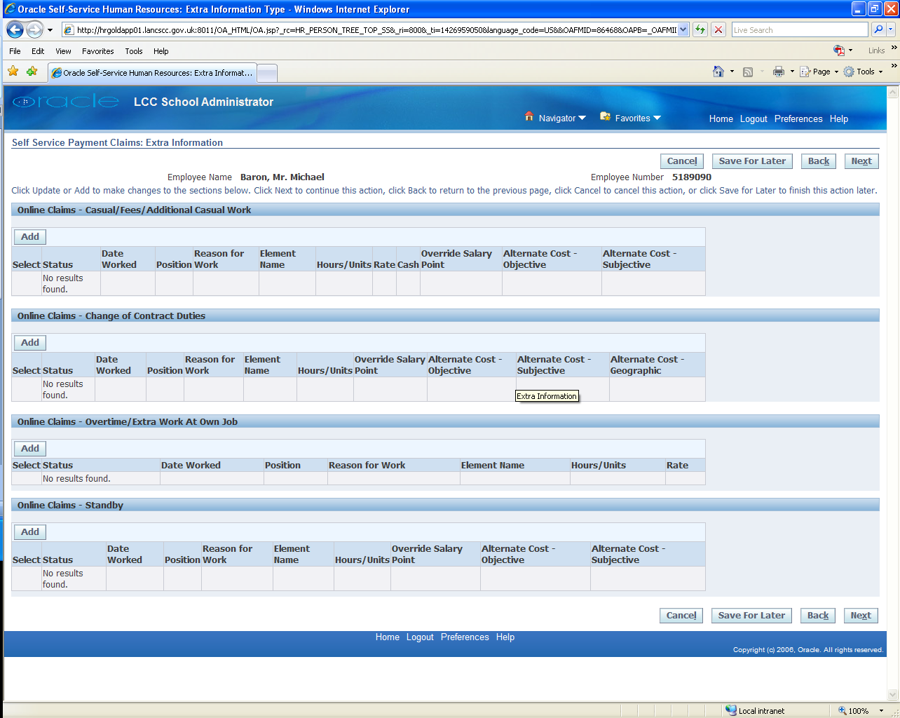

Complete the following sections –

* Date worked.
* Position, select from the drop down list.
* Reason for work.

The element used can be one of two either –

* P336 which is used for claiming hours or
* P337 which is used for claiming full days.

**Teachers must not use element P440, if this element is used the wrong payment may be made.**

The two examples below show a claim for hours and a claim for days.

Claim for Hours

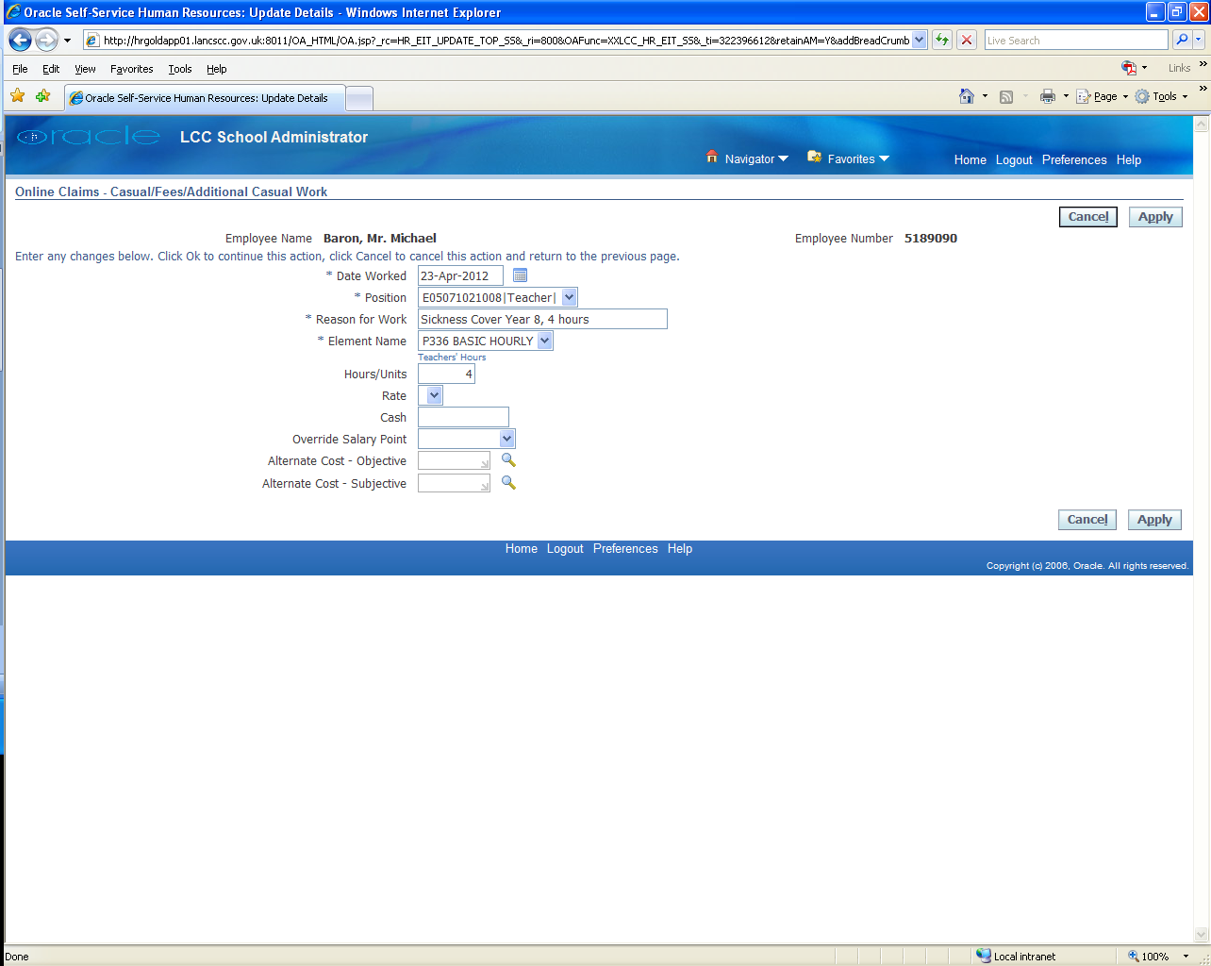

Claim for Days

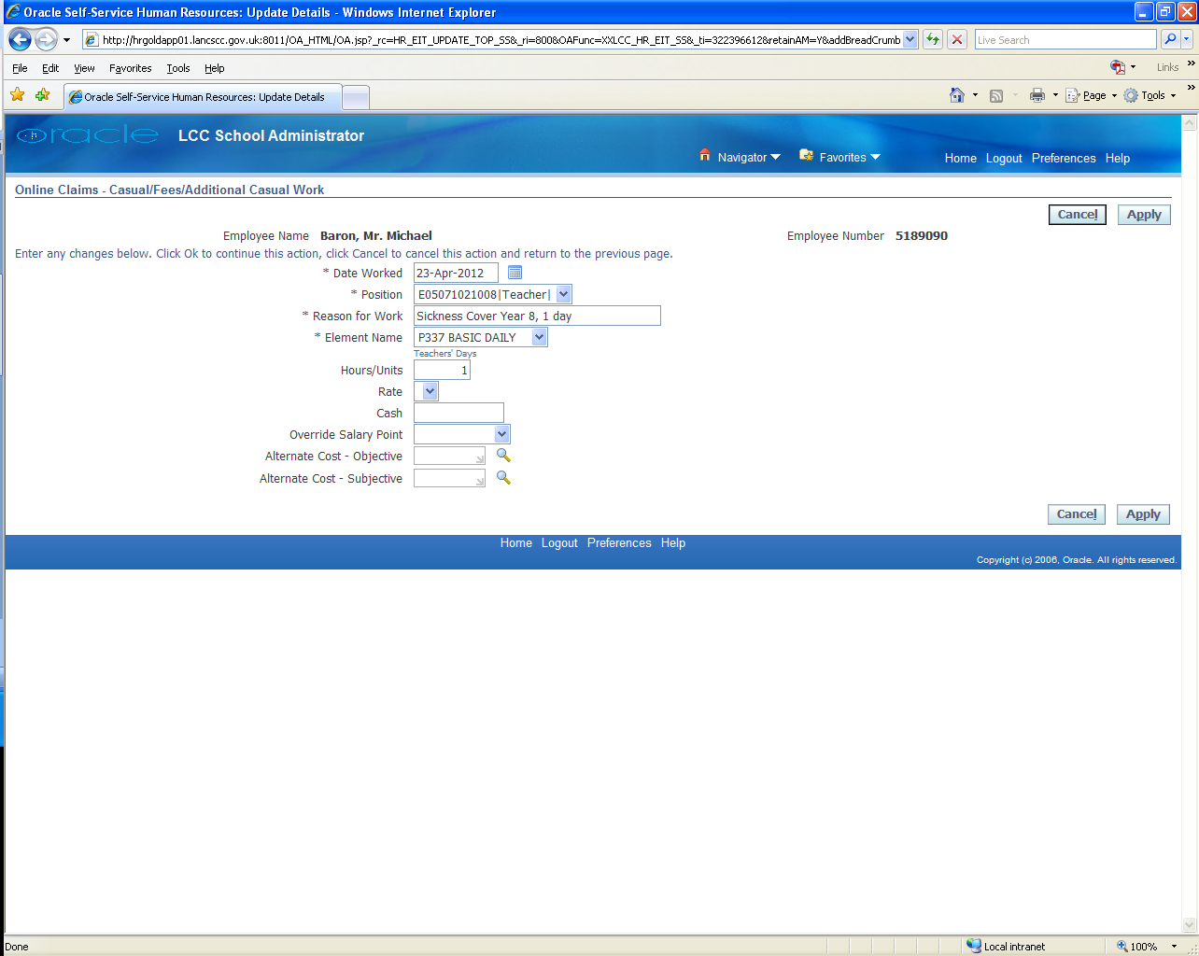

Once the above claims are complete they can be submitted to your authoriser and when approved will be paid in accordance with the published Payroll deadlines.