**How to Input Qualifications on Oracle**

1. Qualifications can be entered on to Oracle using LCC Employee Self-Service.
2. From the menu select 'Qualifications and Professional Details' as below, then 'Educational Qualifications'.

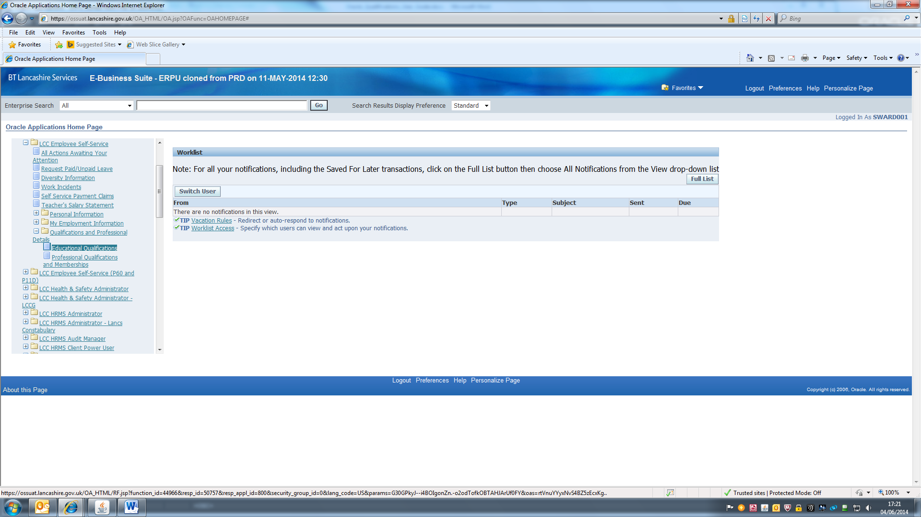

1. Click on 'Add Qualification' to input a new one.

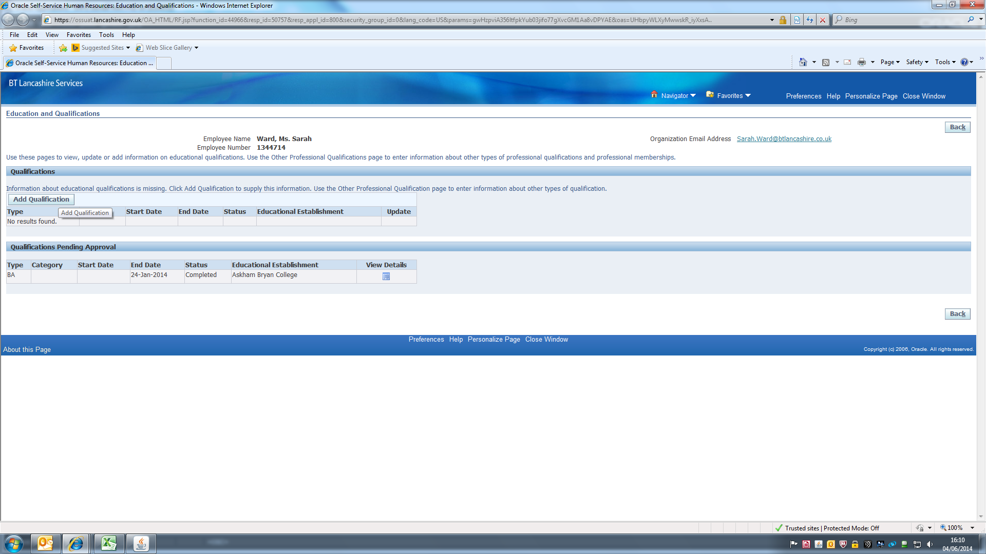

1. The qualification screen is as below.

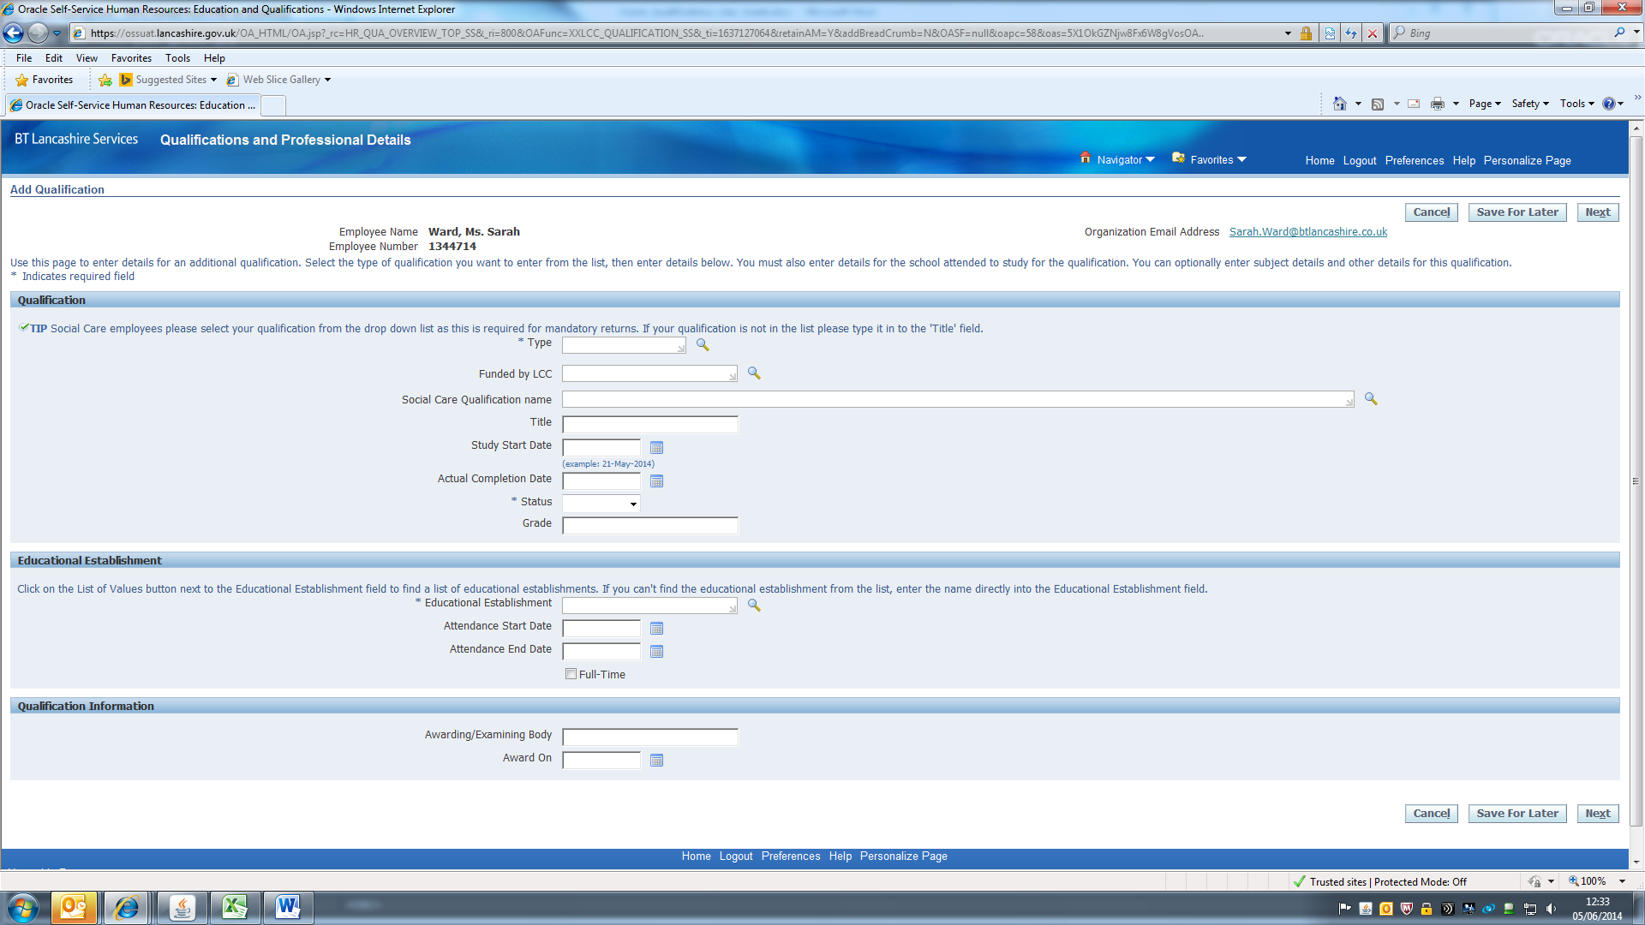

1. A qualification 'Type' must be entered but you can search from the list by putting in a key word or term e.g. BA, BSc, NVQ, A Level, (use Cert for certificate).

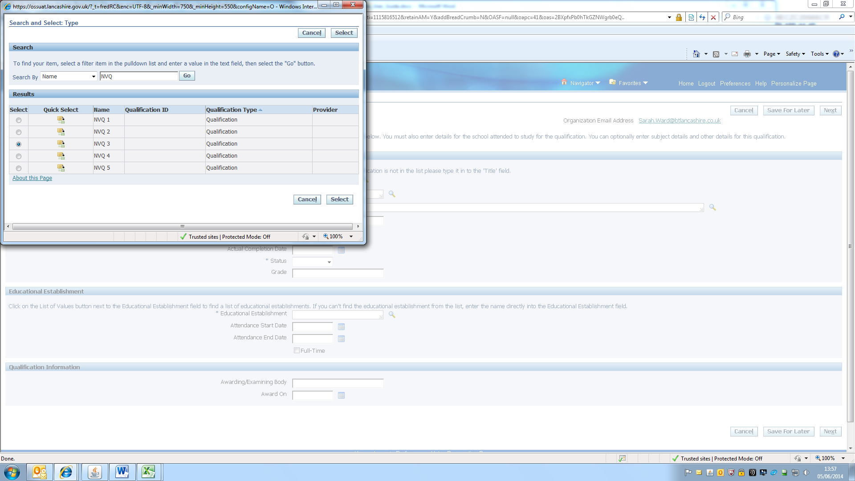

1. The 'Title' field, which is free text, can be used to type in the qualification name.
2. Social Care Employees: Please use the search window to see the list of qualifications that has been provided as we have a responsibility to report on this (Please note: any information released that is related to the workforce is always anonymous).

Press Go to see the full list of qualifications or type in a key word to search.

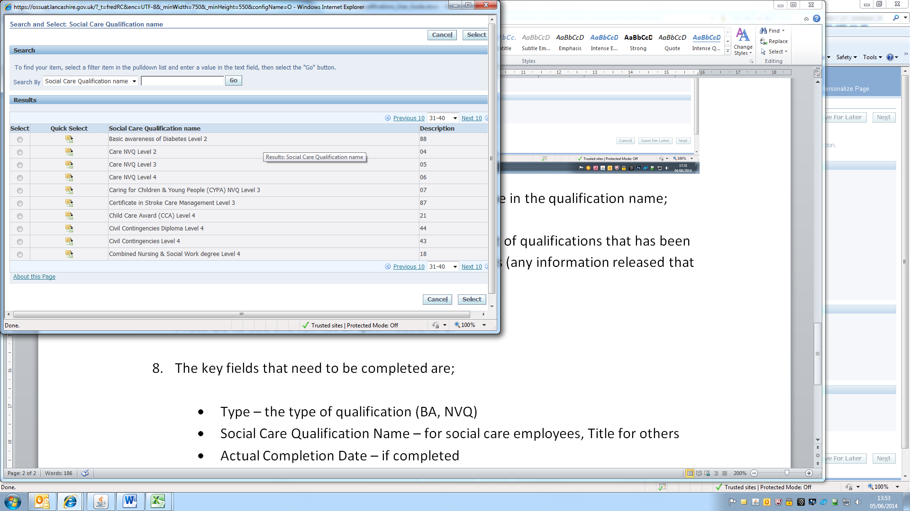

1. Select the qualification required and complete the rest of the form in the same way.

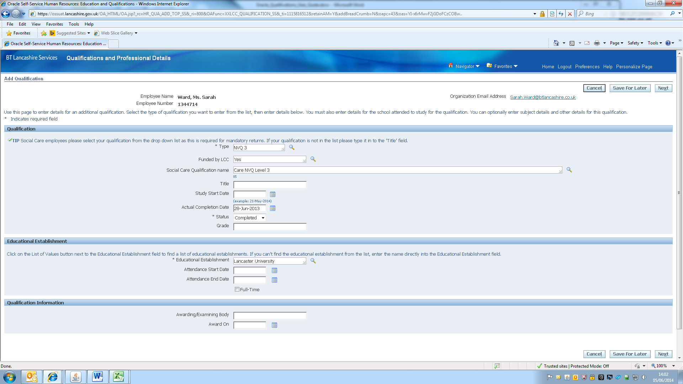

1. The key fields that need to be completed are:

* Type – the type of qualification (BA, NVQ)
* Social Care Qualification Name – for social care employees, Title for others
* Actual Completion Date – if completed
* Status – Completed or In Progress
* Educational Establishment – mandatory field, if not in list use 'Other'

1. When the form is complete click Next at the bottom right of the screen.
2. You should see this summary page. Click on Submit at the bottom of the screen and the details will be sent to your manager to be approved. Managers should ensure that they have seen the original qualification documents before approval.

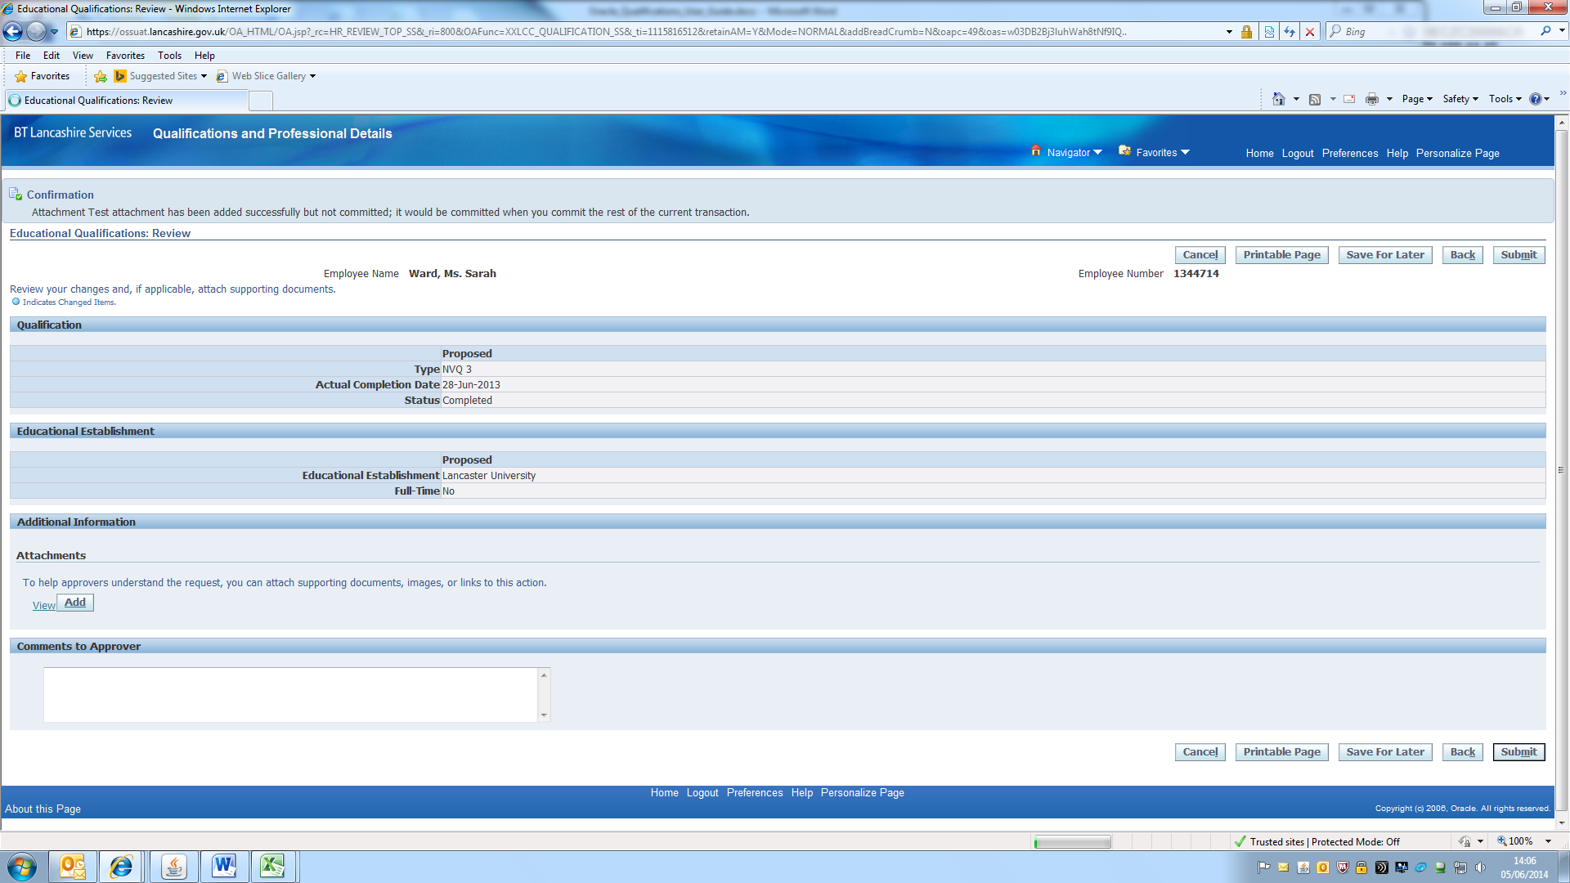

1. Confirmation of the details being submitted will appear as below. Click on Home to return to the main menu. You should also see a notification in your Worklist on the Oracle front screen.

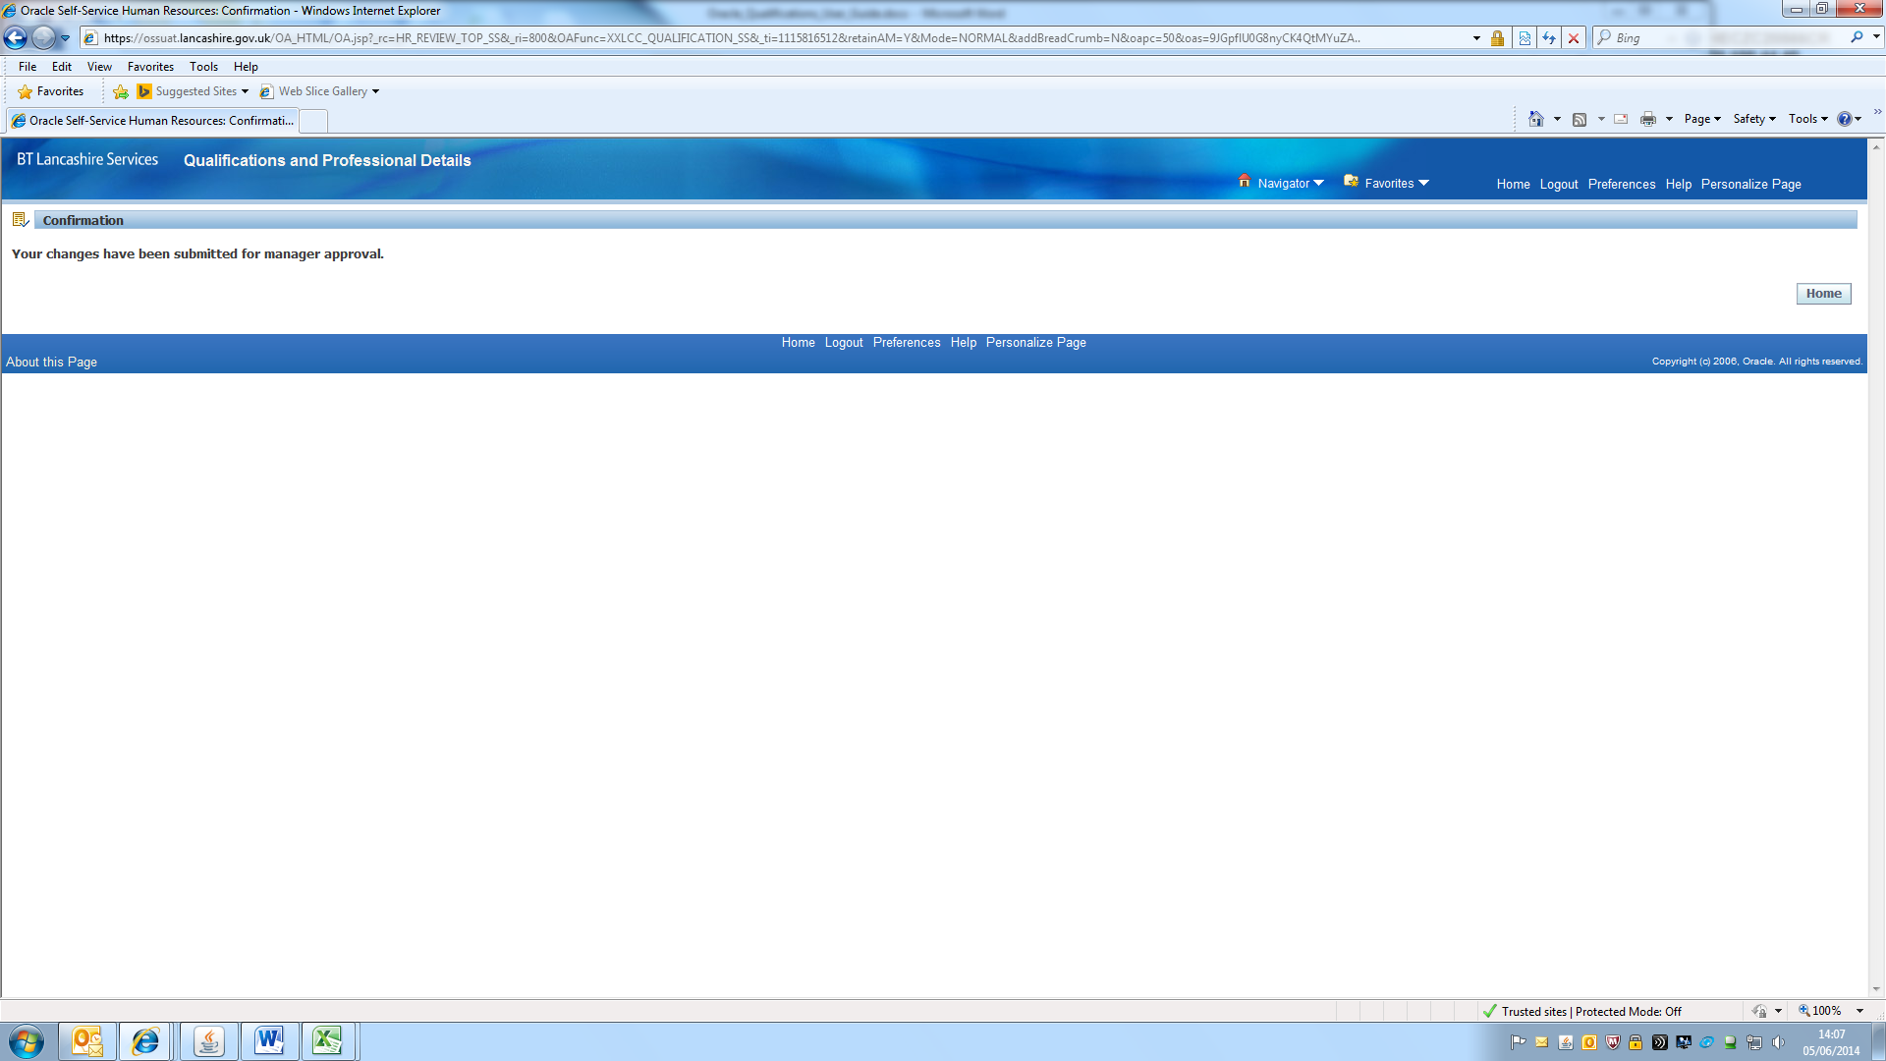

1. The manager should receive a notification that a qualification has been entered and be able to approve it as normal.
2. Please note that any documentation that is attached to the request will disappear from the system once the qualification has been approved.

**Additional Information**

1. Managers can input qualifications on the employee's behalf if required
2. Professional memberships such as social worker registration details can also be entered via the 'Professional qualifications and memberships' link on the self-service menu.