Dear Colleague

**Lancashire Teaching Agency (LTA) Invoicing Procedures**

Thank you for choosing to use the Lancashire Teaching Agency for your school's supply needs this term. The LTA is committed to enhancing the service offer to schools, ensuring an excellent prompt service and providing high quality staff matched to schools' requirements.

**Benefit of school using LTA**

An additional benefit of using the Lancashire Teaching Agency for supply services is the reduced administrative and management burden for schools through centralised billing procedures with statements and timesheets accessible under the “LTA” section of “my school folder” on the [Schools Portal](https://schoolsportal.lancsngfl.ac.uk/). This enables quicker transfer of information to assist schools in balancing their accounts.

**Authorisation of Timesheets**

|  |  |  |  |  |  |  |  |  |  |  |  |  |  |  |  |  |  |  |  |  |  |  |  |  |  |  |  |
| --- | --- | --- | --- | --- | --- | --- | --- | --- | --- | --- | --- | --- | --- | --- | --- | --- | --- | --- | --- | --- | --- | --- | --- | --- | --- | --- | --- |
| |  |  | | --- | --- | | Booking Filled   |  | | --- | |  | | |  | |  | |  | |  | |  | | Timesheet uploaded by consultant – confirmations via Joined Up sent. | |  | | Hours submitted by candidate by close of play Friday by accessing the Joined Up system | |  | |  | |  | |  | |  | |  | | School authorises on Friday by accessing the Joined Up system | |  | |  | |  | |  | | LCC raise journals and invoices to schools | | Statements and Timesheets are posted on the Schools' Portal | |  | |  | |  | | Teachers and Support Staff are expected to input their own hours onto the [Reed 'Joined Up' system](https://clickweb-admin.ad.lancscc.net/modules/clicksuite/clickweb/media/doc.asp?id=143842&mode=edit) or confirm them over the phone with their Consultant by Friday evening at the latest each week. The school do not have the facility to do this as the system is designed to give the candidate control.  School managers [authorise weekly timesheets](https://app.joinedup.com/login) using the 'Joined Up' system, reminders will be sent out by consultants to prompt the authorisation on <https://app.joinedup.com/login>. In the unlikely instance that a School Manager cannot authorise a candidate timesheet, a nominated Reed consultant will act as an approved proxy and authorise the timesheet, in order to guarantee that a candidate is paid on time. Reed employed teachers and support staff are paid every Friday. LCC employed teachers are paid monthly on the last working day of the month.  If schools have not used the system previously login details are available at the local LTA branch. |

**When do I get billed for supply staff?**

At the end of the month after the supply work has been carried out, the school is billed either by raising a journal transfer through the Oracle Financials system or invoiced directly to the school with VAT charged where appropriate.  Unlike some other supply agencies, LTA provide clear and transparent information on the scale of charges to schools specifying what is paid to the worker, the on-costs (i.e. PAYE, National Insurance and Pension costs) and the management costs.

**How do I access 'My School Folder' on the Schools Portal?**

Invoices, statement and timesheet information are available through the School Portal through usage of the “my school folder” under a separate section marked “LTA”.

There is a guide available on the Schools Portal for Supervisors to grant My School Folder user access [**https://schoolsportal.lancsngfl.ac.uk/view_sp.asp?siteid=3348&pageid=8964&e=e**](https://schoolsportal.lancsngfl.ac.uk/view_sp.asp?siteid=3348&pageid=8964&e=e):

**Step 1:** Once logged into the Schools Portal as a Supervisor - On the Schools Portal Home page, select 'Account Management' from the left hand side

**Step 2:** From there, click 'My School Folder'.

**Step 3:** From there, click 'Change Access'.

**Step 4:** You should now see a list of Usernames and the sub-folders already assigned to them. (Usernames and names removed)

**Step 5:** To the right of User Name and Subfolder, select the plus symbol +

**Step 6:** You should now see two tab options: 'Username' and 'Sub-folder'. Click the **'Username'** drop down arrow and select the relevant user. (Usernames and names protected within this example)

**Step 7:** Now the user has been selected, select the **'Sub-folder'** drop down list. This will generate a list of all the available systems. Note: the list will only show sub-folders that they do not currently have access to. Then select desired sub-folder. (Usernames and names protected within this example)

**Step 8:** Now both user and sub-folder chosen - Select the **'Save'** button. (Usernames and names protected within this example)

**Step 9:** This has now completed the process. To check that you have been successful, return to the page containing the list of usernames and sub-folders as shown in **Step 4.**

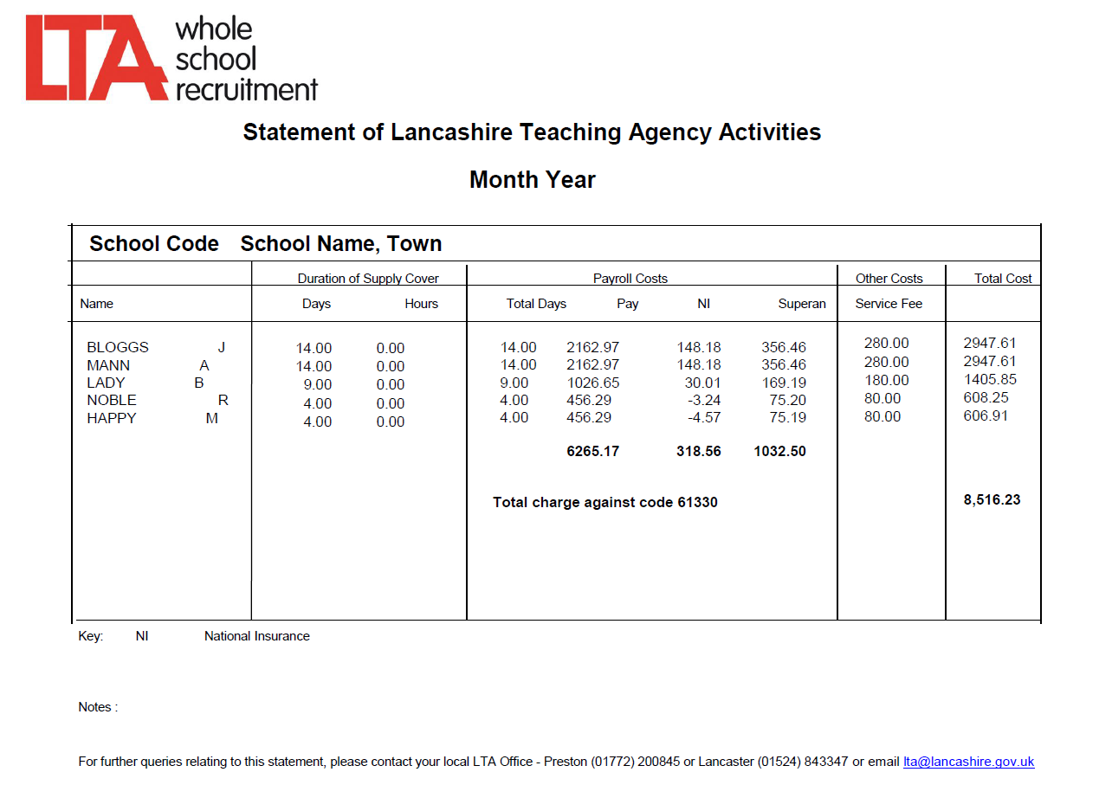

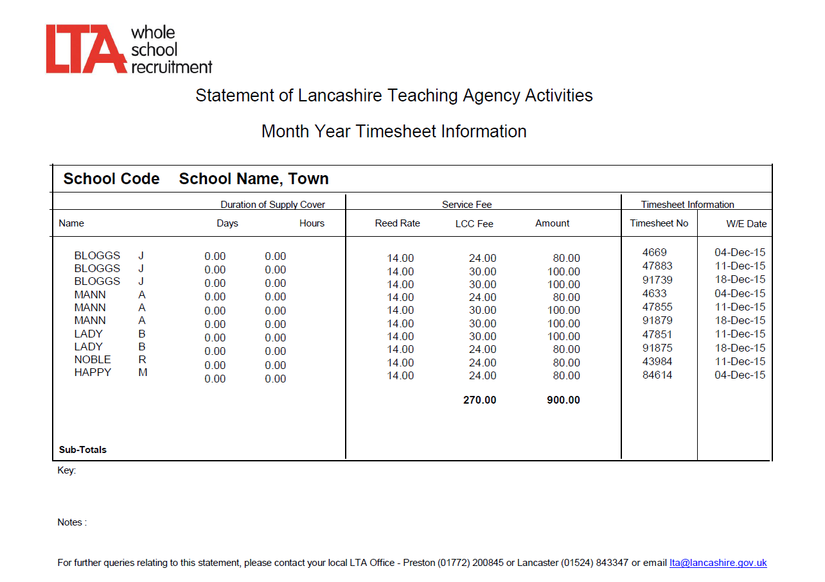

Bank account schools will be invoiced on a monthly basis when LTA supply staff have been used. The payment of this invoice is required within 30 days, further details of the payment procedure will be included with your first invoice.

**How do I reconcile monthly against Oracle?**

The Oracle invoicing process /bank account charges are processed monthly under the subjective codes for LTA billing - support staff (61331) and teachers (61330).

It will therefore be possible to balance each subjective code exactly to Oracle by simply checking the totals against the statements.

The timesheet information is available for schools to reconcile the authorised timesheet against school records.

It is the schools responsibility to ensure Oracle and Finance 6 are reconciled on a monthly basis and any irregularities are resolved promptly by the school.

**I have a query regarding my LTA invoice, who should I contact?**

If you have any queries regarding receipt of your statements and timesheet information please email LTA@lancashire.gov.uk detailing your concerns. Claire Hilton (LTA Project Manager) is available to address any concerns on 07786 197149.

The LTA looks forward to continue to work with you. If you would like to discuss any vacancies with LTA, please **E-Mail:** [lancashire.teaching@reed.com](mailto:lancashire.teaching@reed.com) or call on:

|  |  |
| --- | --- |
| **Lancaster:** 01524 843347 | **Preston:** 01772 200845 |
| **Secondary Team:** (01772) 567302 |  |

The LTA provides:

* **Temporary short and long term cover** through supply teachers, teaching assistants and the full range of support staff roles.
* **A specialist recruitment service** to best match the needs of the school to the skills of the supply staff; Candidate choice and quality provision with 700 teachers and 200 Support Staff.
* **Fully IR35 compliant employment arrangements** with all staff paid through payroll with the necessary deductions
* **Rigorous safeguarding practices** to ensure all staff are compliant with current Ofsted and Council requirements including commitment to following an appropriate safer recruitment and selection process (and signing of the Supply Agency Safer Recruitment and Selection Checklist). In addition previous LCC employment records of LTA supply teachers and support staff are checked upon appointment, for the purpose of determining suitability to be re-employed within the Council, in a role that is incompatible with the reasons that any previous employment ended.
* **High quality supply staff** with all LTA staff required to attend a compulsory induction and safeguarding session during their first term of employment; Free CPD for all staff through LPDS.
* **Two offices** with highly trained consultants to match school requirements, accessible 24 hours a day in addition to Reed network of offices nationally.
* **A Membership Scheme** to allow schools to make savings on both their temporary and permanent recruitment;
* **FREE transfer to contract after one term** – a unique feature of LTA.
* **Transparent pay and charge** and monthly invoicing by LCC for all categories of staff; Control of costs through reduced management fees, which are clearly listed on the invoices.
* Staff who are **deployed on Local Authority (LA) standard job descriptions** and are paid in line with the grading structure for these posts;
* Ability to **view CVs** of LTA teachers and support staff who are currently available for long term and permanent positions accessible on the Schools' Portal.

LTA offers a flexible charging model for schools in their use of supply teachers. As a result, varying pay rates are available for assignments of up to 30 consecutive working days. All teachers engaged on assignments of over 30 consecutive working days are paid at a rate equivalent to the national pay scales.

Kindest regards.

Claire Hilton

LTA Project Manager

People Services

Lancashire County Council

Mob: 07786 197149  
Website: [- Lancashire Teaching Agency](https://clickweb.lancashire.gov.uk/?siteid=3504&pageid=10028&e=e)