Where data appears to be missing on the Planned Absence Report - This is a sorting issue, unfortunately the default sort on this report is a group sort and the gaps are where it's saying 'same as above', it is sorting them in to a group.

To get rid of it and make all the data appear you can go in to 'Sort' and then 'More' and then change all the sorts to 'Normal' instead of 'Group' as below.

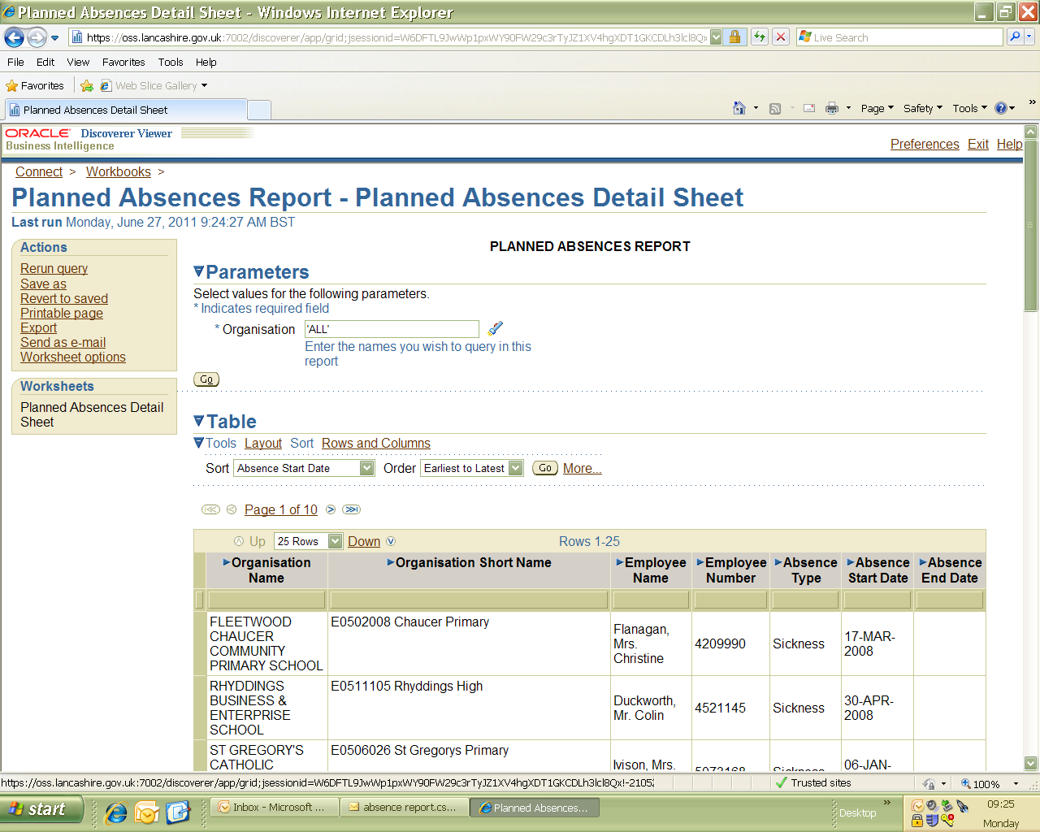

Press 'Sort', then 'More' to access the sort functions.

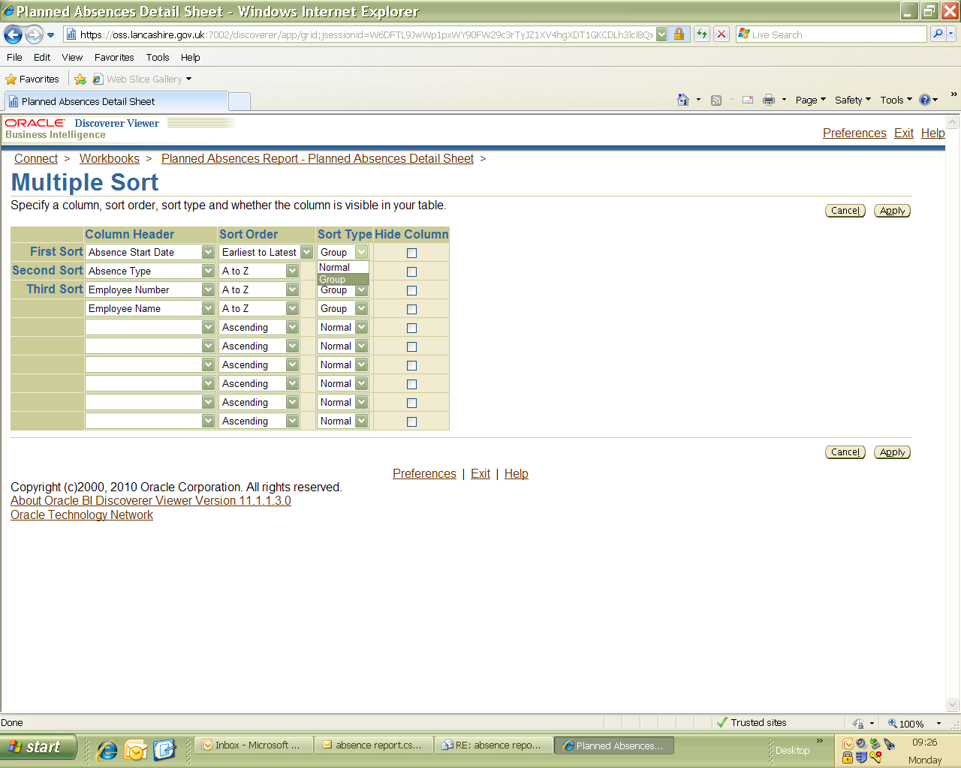

Change all sort types to 'Normal' sort.