## Deleting Absences in Oracle

You are now able to delete absences from your employees' records with the exception of:

* Adoption leave – Self service
* Jury Service
* Maternity – Self service
* Maternity Support Leave
* Paternity Leave – Self service
* Suspension – unpaid

You should now correct your team's absences as necessary.

Sickness absences: only the latest absence can be deleted, you will receive an error message if you try to delete an earlier sickness absence.

All other absences, including leave, can be deleted at any time even if the leave date has passed.

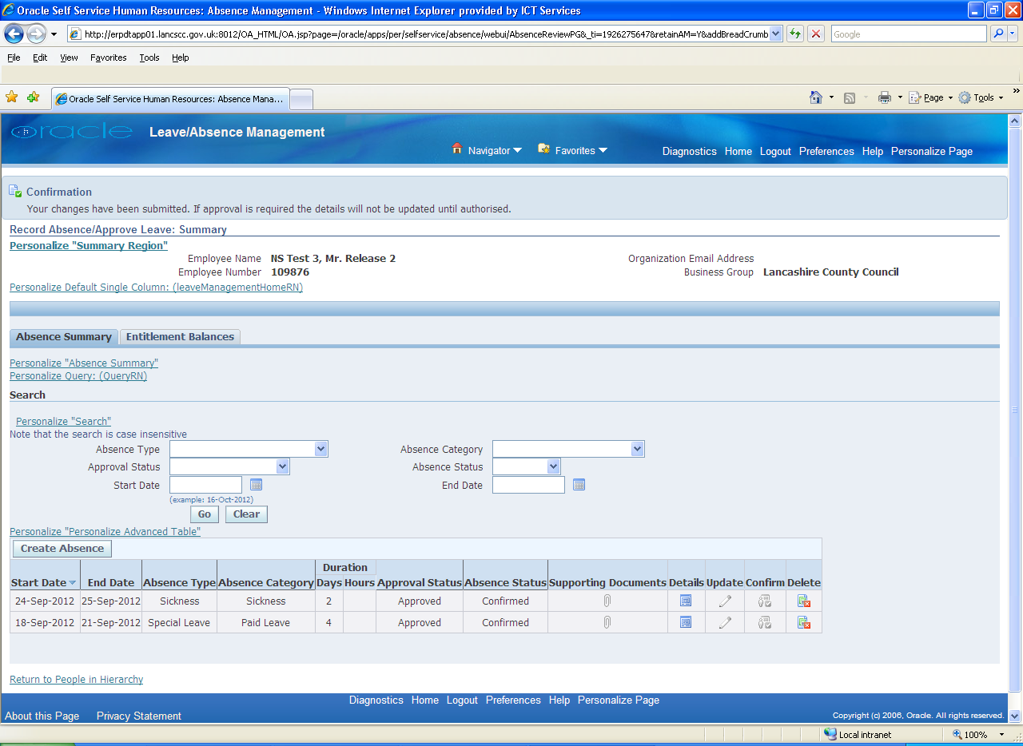

Use the delete button to remove absences from your employees' record.