

BT Lancashire Services

Guidance Notes – Entering GSCC Details into Oracle



**Working in partnership**

Under LCC Employee Self-Service, click on the + alongside 'Qualifications and Professional Details' to expand the options available and select 'Professional Qualification and Membership.

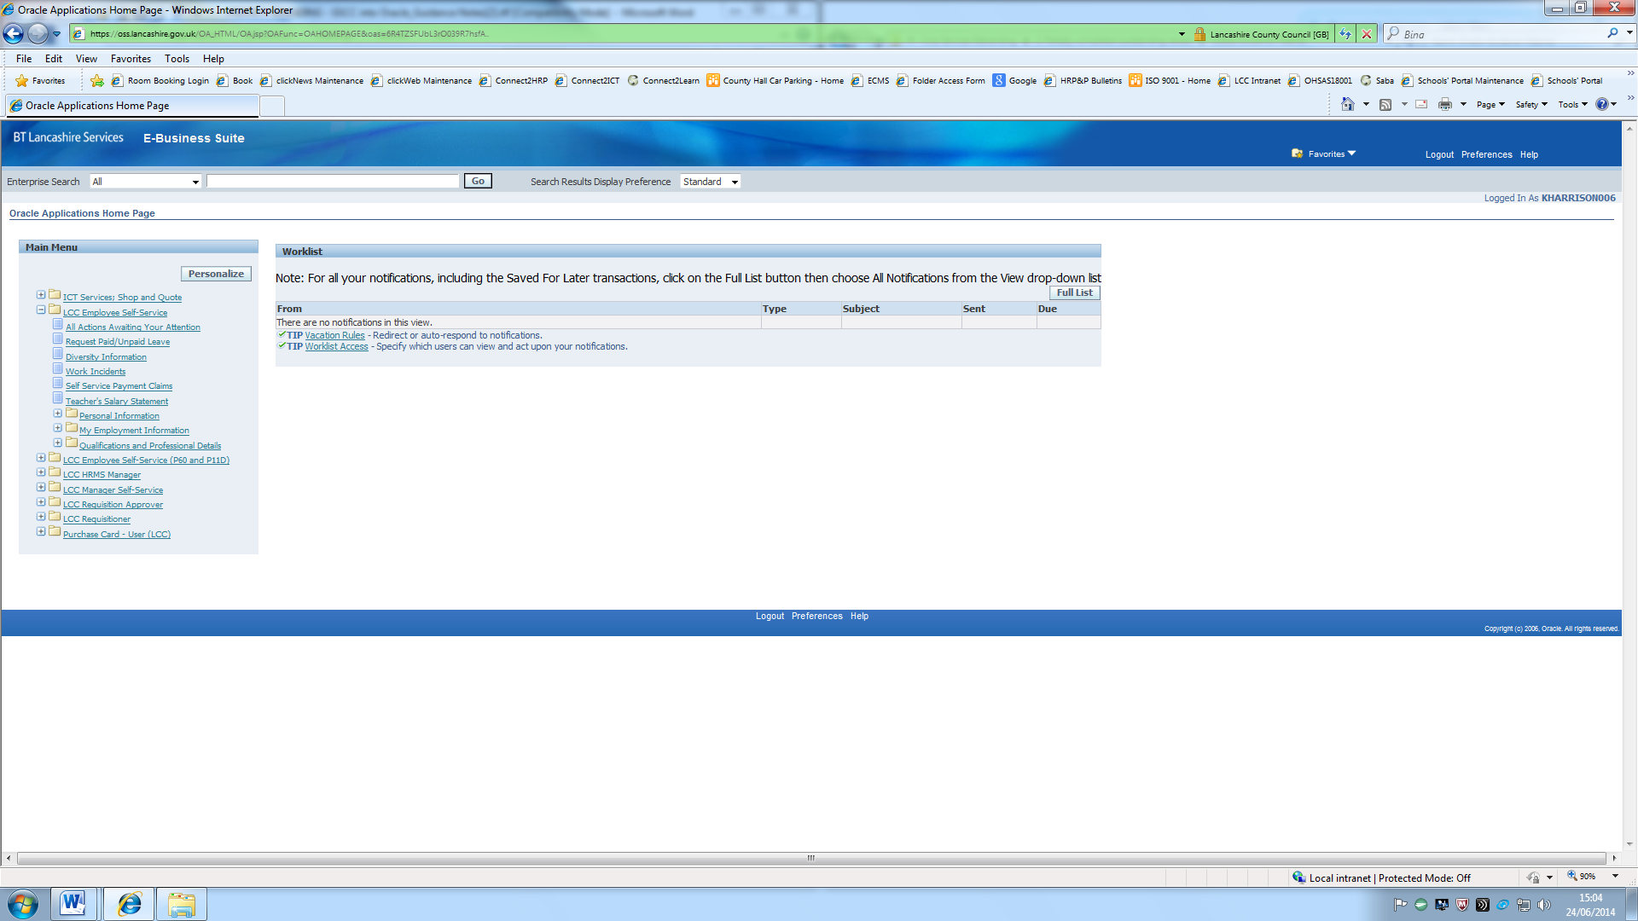

Click on 'Add Professional Qualification'

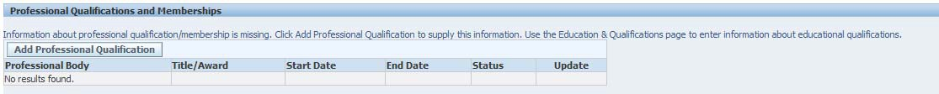

In the first section entitled 'Professional Membership', click on the spyglass alongside

'Professional Body'

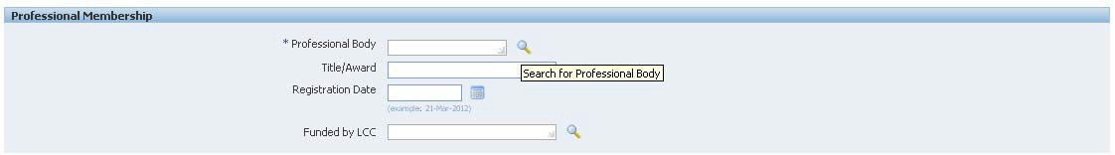

In the search field, type 'General' and click on the 'Go' button.

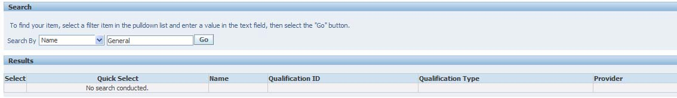

Select GSCC and click on the 'Select' button.

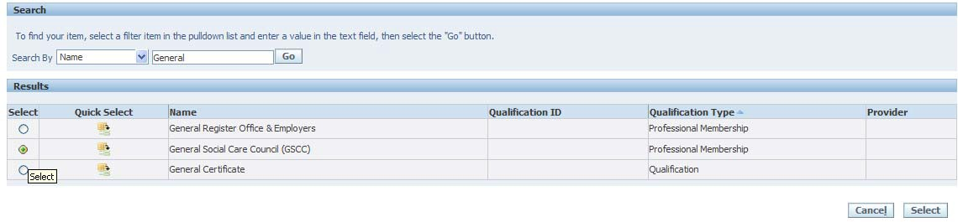

Then enter all the details against the remaining fields, especially the 'expiry date' as this is what governs the 'alerts' in the system.

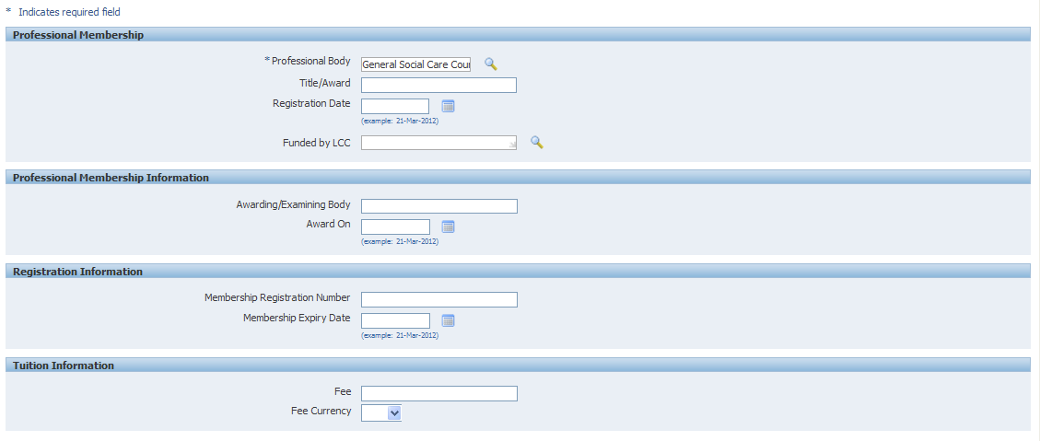

When all the details have been entered, click on the 'Next' button, review your details then submit the request to update your details to your authorising Officer.