Quick Guide to Request Your Forgotten Username or Resetting Your Password

At the main Oracle self service login page, click on the 'Forgot Username/Password. Click here' button.

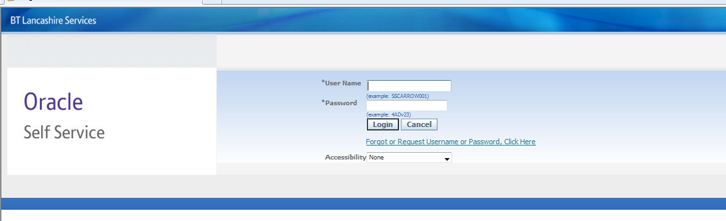

You will see the following screen:

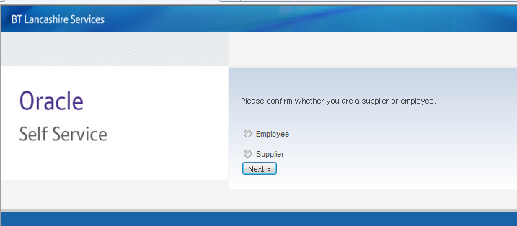

Click on either 'Employee' or 'Supplier' – whichever is applicable and you will see the following screen:

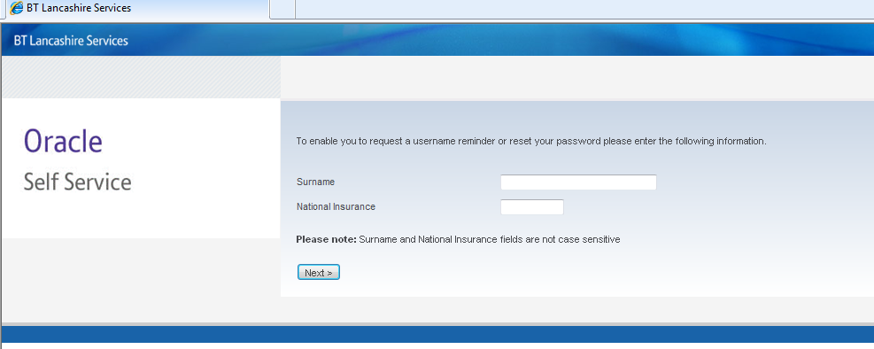

Whether you have forgotten your username or password or both, enter your surname and national insurance number as requested then click on 'Next'. You will see the following screen (a).
If you have not got an email address in the Personal Information field in Oracle self service, you will also be asked to enter your date of birth. See following screen (b).

(a)
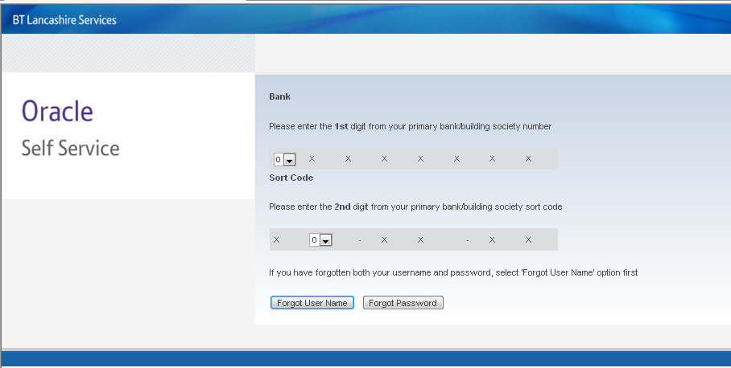

(b)

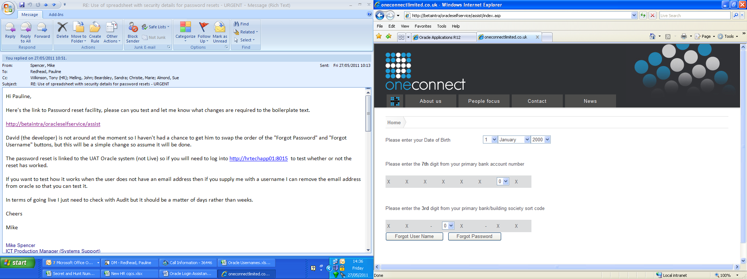
Enter the details as requested. Your primary account is the main account that your salary is paid into. Select either 'Forgot User Name' or 'Forgot Password'. If you have forgotten both, select 'Forgot User Name' first. Note: If your main account is a building society account, you will be asked for random digits from the roll number and you need to count the '/' and the' –' as digits. For example, in the illustration below, it is asking for the THIRD digit including the '/'.

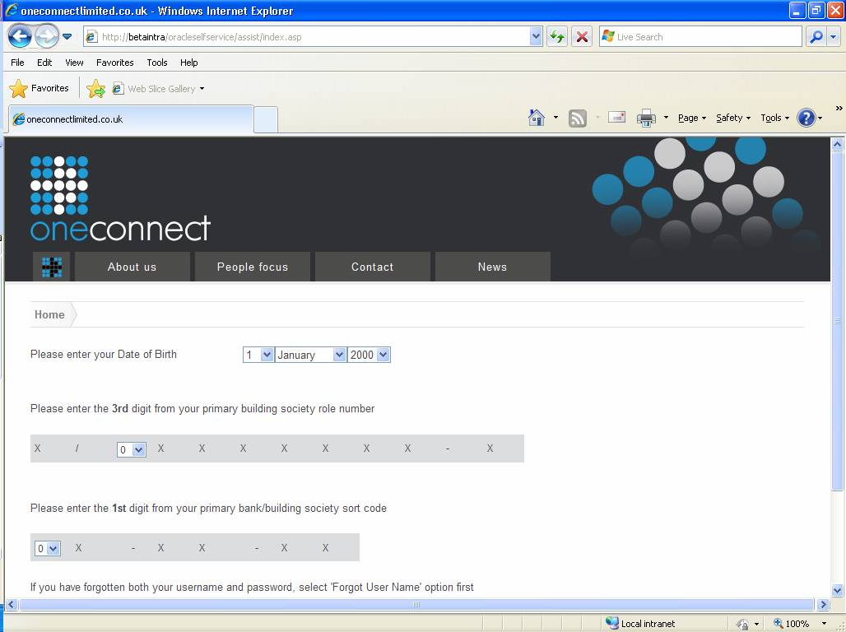

If you have got more than one pay reference number and therefore more than one Oracle Username, you will also be asked to decide from a drop down list, which post you want to reset. See below:

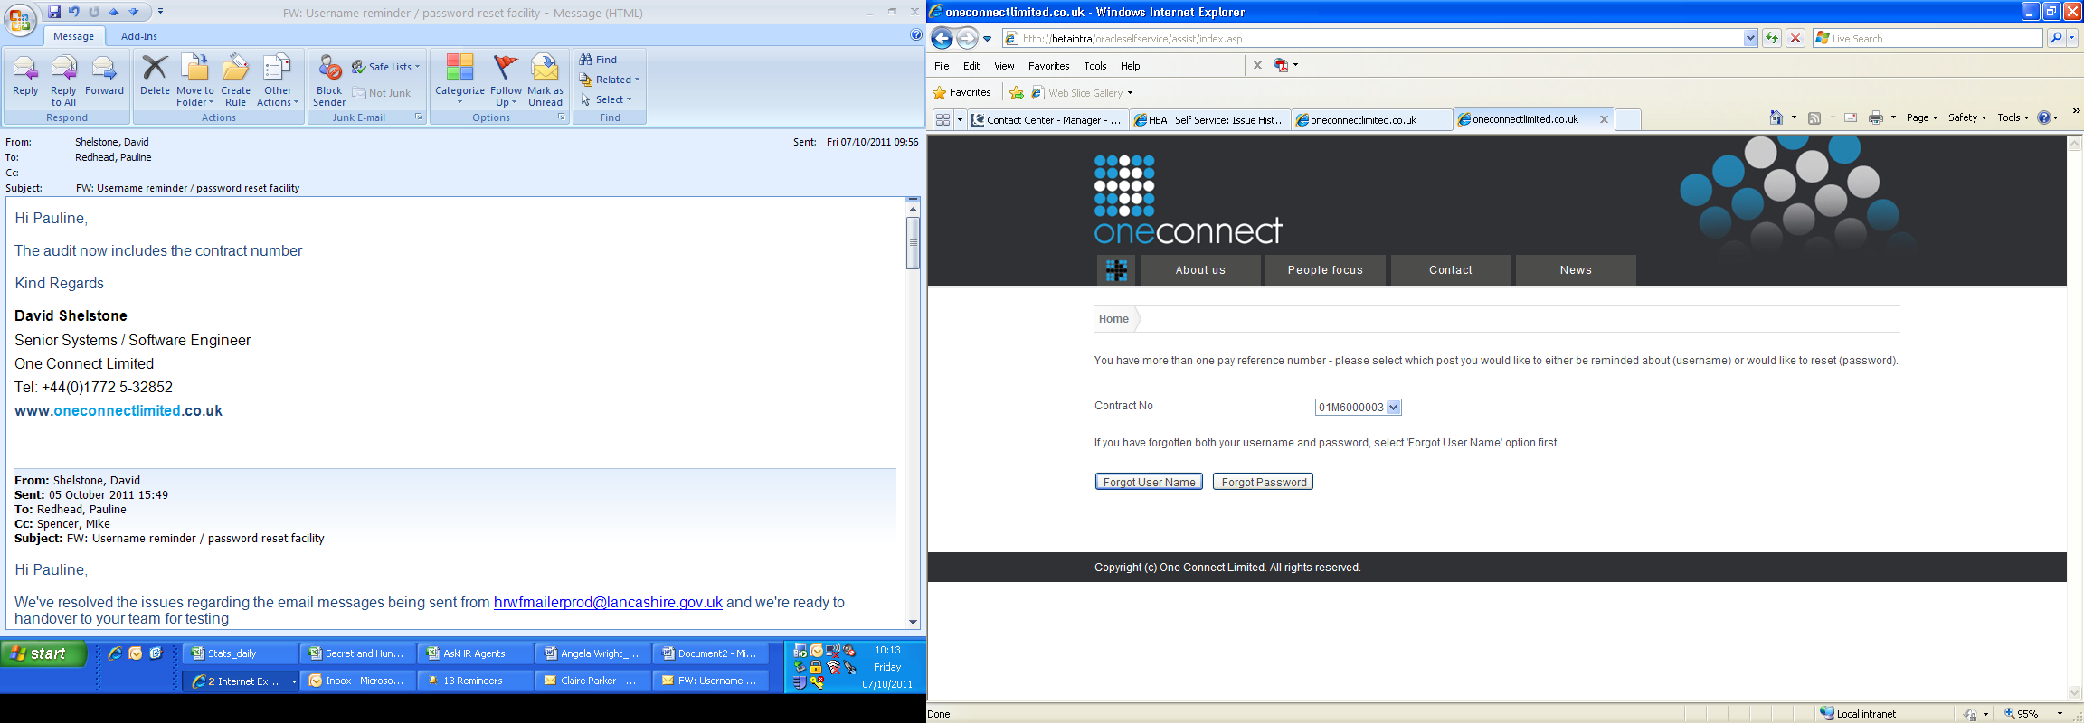

Forgot User Name
If you have got an email address in the Personal Information within Oracle self service, your username will be sent to your registered email address. You can now use this to log into Oracle self service (see below).

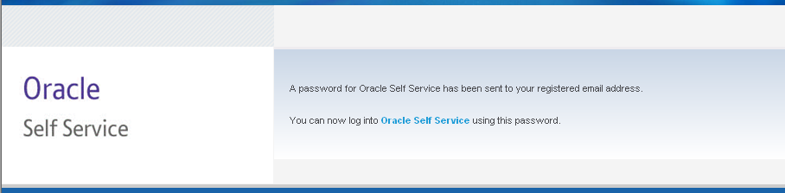

If you have NOT got an email address in the Personal Information within Oracle Self Service, your User Name will appear on screen. You can now use this to log into Oracle self service. Please take the time to enter your email address (preferably your work's email address) in Oracle self service the next time you log in.

Forgot Password
If you have got an email address in the Personal Information within Oracle Self Service, a temporary password will be sent to your registered email address containing a random set of numbers and letters. You will then need to log into Oracle self service using this temporary password. Please note that this random sequence of numbers and letters is case sensitive and should contain no spaces. Once you enter this temporary password, you will be prompted to re-enter it then create (and confirm) a new password. Your new password cannot be any that you have used previously and again, is case sensitive. You cannot use repeating characters and, for improved security, should have a mix of numbers and letters.

If you have NOT got an email address in the Personal Information within Oracle Self Service, a random sequence of numbers and letters will appear on screen. You will then need to log into Oracle self service using this temporary password. Please note that this random sequence of numbers and letters is case sensitive and should contain no spaces. Once you enter this temporary password, you will be prompted to re-enter it then create (and confirm) a new password. Your new password cannot be any that you have used previously and again, is case sensitive. You cannot use repeating characters and, for improved security, should have a mix of numbers and letters.

Important Information
- Please remember that the generic Oracle e_Learning username and password is different from that for Oracle Self Service
- Oracle Self Service login details are sent to all employees by letter.
- The very first time you log into Oracle Self Service, you will need to click on 'forgot username or password' to be issued with a temporary password which you can use to log in for the first time. You will then be prompted to create a new password for yourself.
- Leave the "Accessibility" field on the Oracle login page as "None"
- Passwords should be a minimum of 6 characters, contain at least one letter and at least one number, should not contain the username, should not contain repeating characters and will be case sensitive
- You will only get 3 attempts to enter your password correctly to avoid being locked out of the system (contact AskHR if this happens)
- The password will expire after 60 days and you will be prompted to create a new one
- A password cannot be re-used until 365 days has passed
- When you know your password but want to change it manually, log into Oracle Self Service then click on 'Preferences' at the top right hand side of the Oracle homepage and scroll down to the 'Change Password' section. You will be prompted for your current password together with the option of creating a new one
- If you have access to the LCC intranet, you will find guidance from ICT on setting passwords:
http://lccintranet2/corporate/web/?siteid=4305&pageid=19031&e=e

