

ENVIRONMENT DIRECTORATE

BRIDGE INSPECTION
REPORT OF december 2004

STRUCTURE NAME: REAR LYNDHURST ROAD CULVERT

STRUCTURE No.: B6487

GRID REF.: 384835 432265

Date Inspected: 14th. December 2004

Inspected by: P. Robinson-Waddington.

Graham Harding BEng CEng FICE FIHT MIMgt
Environment Director
Lancashire County Council
PO Box 9, Guild House
Cross Street
PRESTON PR1 8RD

CONTENTS

Page

Site Map 3

Description of Structure 3

Maintenance History 4

Description of Inspection 4

Results of the Inspection 5 - 6

Overall Structure Condition and Recommendations 7

List of Photographs 7

Location Plan for Photographs 8

Photographs 9 - 25

Detailed Plan (not to scale) 26

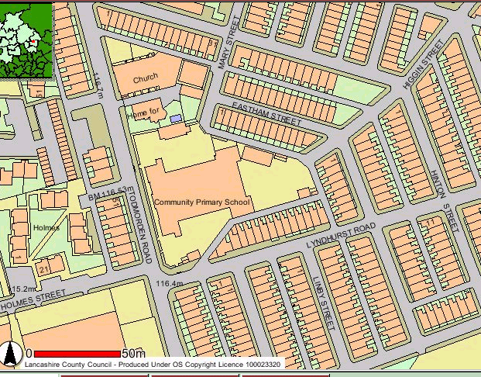

Site Map. (not to scale)

DESCRIPTION OF STRUCTURE

STRUCTURE NAME: REAR LYNDHURST ROAD CULVERT
STRUCTURE No.: B6487

1). Chainages 158.00 to 203.00

The culvert is a 2 ring brick pipe of nominal 1.220m diameter running almost parallel to and beneath the boundary wall along the access from Lyndhurst Road to Rear Lyndhurst Road. Over time the culvert profile has flattened, particularly beneath the boundary wall. The boundary wall runs from ch. 160.00 to ch. 190.50. The culvert changes section and direction at ch. 203.00.
In order to prevent any further vehicular loading on the culvert a fence has been erected and vehicular access prohibited.

2). Chainages 203.00 to 242.00

The culvert beneath the school playground to the rear of the school is of rectangular section, 1.050m deep by 1.300m wide. It is constructed of brick walls on a slab base. The walls carry riveted boiler plates and 1.000m of fill to the playground level. (note: this is the same construction as the culvert in Higgin Street before redecking in 2003)

MAINTENANCE HISTORY

Date | Description of Maintenance / Inspection | Location of Repairs / Maintenance
November 1998  Sept. 2003 | Replace bricks to soffit of brick pipe and point up.  Erection of protective fence. | Soffit. (ch 158 to 165)  Road alongside and above culvert.  (ch 160 to ch190)

Note: the culvert downstream under Lyndhurst Road and Todmorden Road was replaced with a concrete box culvert in 2003.
The culvert upstream in Higgin Street was redecked in 2003.

DESCRIPTION OF INSPECTION

Inspecting Engineer - P. Robinson-Waddington
Assistant Engineer -
Date of Inspection - 14th. December 2004
Weather Conditions - Dry after several dry days.

All exposed faces were closely examined at touching distance inspected for cracking, crazing, spalling and any other indications of deterioration.

The foundations were not exposed for the purpose of a visual inspection, but some indication of performance and integrity was gained by carrying out a visual check on the walls.

The inspection was undertaken in a confined space.

No trial holes were taken.

RESULTS OF INSPECTION, DATED 14th. December 2004
BRICK PIPE (CHAINAGES 158 TO 203)

Components | Inspection Results | Photo (P) No. | Page No | Recommendations / Action | Timescale
Foundations | The invert appears to be in line and level, therefore the foundations are assumed to be in good condition. | 18, 26, 29 | 17, 21, 23 | None. | -
Inverts or Aprons | The invert is clean. | 18, 26, 29 | 17, 21, 23 | None. | L
Barrel | The barrel has widened and the soffit has dropped.  a  b  The brickwork for the whole of the brick barrel is in good condition without spalls or missing bricks.  There is an arch repair at ch. 162. Pointing along the soffit was undertaken in 1998 upto ch. 170 (approx.) and there does not appear to be any further deterioration. Beyond this point there is a longitudinal crack in the soffit of the culvert as far as ch. 185. Beyond this there is no longitudinal crack or sign of movement even though the barrel is deformed. | 17 – 29 | 17 - 23 | Reconstruction or strengthening of barrel required.  Regular inspection required to check if deformation is worsening. | H
  ch. | a | b
  195 | 1.400 | 1.100
  185 | 1.400 | 1.150
  170 | 1.400 | 1.150
  160 | 1.300 | 1.200

Components | Inspection Results | Photo (P) No. | Page No | Recommendations / Action | Timescale
Surfacing | The surfacing in the school playground is in a good enough condition for its purpose without signs of settlement.. There is a small area of shallow puddle in heavy rain.  The surfacing in the access road alongside is in good condition. | 12 | 14 | None at present.
School Boundary Wall | The masonry wall along the access to Rear Lyndhurst Road has a pronounced dip over approx. 8metres. It has been repointed in the past. | 6 – 9, 12 | 11 - 15 | See ‘barrel’ above.

rectangular culvert (CHAINAGES 203 TO 242)

Components | Inspection Results | Photo (P) No. | Page No | Recommendations / Action | Timescale
Foundations | The invert appears to be in line and level, therefore the foundations are assumed to be in good condition. | 13,17 | 15, 17 | None.
Inverts or Aprons | Some minor debris on the invert. The invert appears to be in good condition. | 13,17 | 15, 17 | Remove stones and debris. | L
Walls | There is water seepage along the edges beneath the plates. The brickwork is in good condition but requires repointing in places. | 13, 14, 16 | 15 - 16 | Repoint where necessary when and if culvert is redecked.
Slab | The steel plates on the rectangular culvert to the rear of the school are laminating with a few rivets missing. | 13 - 16 | 15 - 16 | Redecking required.  Regular inspection needed to check on remaining plate thickness. | M
Surfacing | The surfacing in the school playground is in a good enough condition for its purpose without sign of settlement over the culvert. There is a small area of shallow puddle in heavy rain. | 1, 3 - 6 | 9 - 11 | None.

OVERALL STRUCTURE CONDITION AND RECOMMENDATIONS.

Condition

Brick Pipe
Materially the structure is in overall good condition. However, the deformation of the barrel may be on-going. This deformation renders it unsuitable for live loading.

Slabbed Culvert
The steel boiler plates are getting thinner as a result of rusting causing lamination. The substructure is in good condition.

The defects identified by this inspection are ones that affect significantly the load carrying capacity of the structure.

Recommendations

As a consequence of the findings of this inspection report regular inspections are required to both the circular portion (3 monthly) and the rectangular portion (yearly).

Consideration should be given to the replacement or strengthening of the circular portion as soon as possible. The area under the boundary wall may collapse.

Consideration should be given to the redecking of the rectangular portion within the next five years.

LIST OF PHOTOGRAPHS

1). Rear of School from Higgin Street. (Jan 2005)  2). Rear of School from Higgin Street. (Feb 2003)  3). Playground at Rear of School. (Jan 2005)  4). Playground at Rear of School; looking towards Higgin Street. (Jan 2005)  5). Playground at Rear of School. (Jan 2005)  6). Dip I n Boundary Wall; looking from Rear Lyndhurst Road.  7). Gap in Wall (approx. ch. 190.5).  8). Wall over Culvert. (ch. 165 to ch. 190.)  9). Outbuilding at Lyndhurst Road. (ch. 160.)  10). Outbuilding at Lyndhurst Road. (ch. 160.)  11). Outbuilding at Lyndhurst Road. (ch. 160.)  12). Dip in Wall from West Side.  13). Culvert under Playground. (ch. 230 to ch. 242)  14). Culvert under Playground. (ch. 210 to ch. 230)  15). Typical Rusting of Culvert Plates.  16). Typical Rusting of Culvert Plates.  17). Drain Entry. (approx. ch. 208.)  18). Brick Culvert; looking downstream from ch. 203.  19). Brick Culvert; looking downstream from ch. 185. | 20). Brick Culvert; looking downstream from ch. 180.  21). Soffit at ch. 180.  22). Soffit at ch. 175.  23). Soffit at ch. 175.  24). Soffit at ch. 170.  25). Soffit at ch 160.  26). Looking Upstream from ch. 165.  27). Soffit Repair at ch. 162.  28). Soffit Repair at ch. 162.  29). End of Brick Culvert under Lyndhurst Road. (ch. 158)  30). Typical Construction of Culvert in Higgin Street before Redecking.  31). Typical Construction of Redecking of Culvert in Higgin Street.  32). Typical Construction of Redecking of Culvert in Higgin Street.  33). Typical Construction of Redecking of Culvert in Higgin Street.  34). Surfacing to Higgin Street upto School Playground.

Location Plan
For
Photographs

