Branding/Logo
a. When was your current logo/branding implemented?
Lancashire County Council's red rose logo was changed in 2009 in order to save the council money and to re-introduce the Tudor rose, a well known symbol of Lancashire, into all our communications. The revised logo is being introduced on a gradual basis whereby digital versions were made available immediately, but on printed materials the logo is only replaced when existing stock is either exhausted or needs updating. On other publicity materials such as uniforms, livery and signage, the logo is only amended when the items need replacing for other reasons, so no additional cost is incurred.
b. Please provide me with a copy of your logo, and the branding/logo guidelines or other equivalent document.
See Attachment
Domains/Website
c. Please provide me with a list of domain names owned by the council?
14-19focus.co.uk | lancashirehotspot.net | lnw.org.uk
artisancam.co.uk | lancashiremcs.org.uk | mylancashiremyplanet.com
artisancam.com | lancashireparentpartnership.org.uk | mylancashiremyplanet.org
artisancam.info | lancashirepartnership.co.uk | Neec2007.co.uk
artisancam.net | lancashirepioneers.com | Neec2007.com
artisancam.org | lancastercastle.com | Neec2007.org
artisancam.org.uk | lances.org.uk | nowcard.org
ascnw.org.uk | lancscc.biz | nwnwsfc.org
cape.org.uk | lancscc.co.uk | outdoor-education.co.uk
Cleo.net.uk | lancscc.com | ptinformation.co.uk
Cleo.org.uk | lancscc.eu | q2a.co.uk
craftsmans.co.uk | lancscc.gov.uk | redrosecrew.co.uk
creativelancashire.org | lancscc.info | safe2travel.co.uk
eastlancsadultlearning.co.uk | lancscc.net | saferlancashire.co.uk
forestofbowland.co.uk | lancscc.org | safertravelunit.co.uk
forestofbowland.com | lancsfire.gov.uk | schoolsportal.lancsngfl.ac.uk
forestofbowland.info | lancsgreentourism.com | servinglancashire.org.uk
forestofbowland.org | lancsmuseums.gov.uk | sharedwheels.co.uk
fosteringinlancashire.co.uk | lancsngfl.ac.uk | steps4me.co.uk
fosteringinlancashire.com | lancsngfl.org.uk | steps4me.co.uk
grinupnorth.net | lancsonline.co.uk | steps4me.com
grinupnorth.org.uk | lancspartners.co.uk | steps4me.org.uk
lancashire.cc | lancspartners.com | theadultcollege.org
lancashire.gov.uk | lancspartners.eu.com | theforestofbowland.com
lancashireadultlearning.co.uk | lancspartners.info | transportforlancashire.com
lancashireadultlearning.com | lancspartners.net | unisonlancs.org.uk
lancashireadultlearning.net | lancspartners.org | westfield.lancsngfl.ac.uk
lancashireadultlearning.org | lancspartners.org.uk | whatnow.co.uk
lancashirecollege.com | lancs-pensions.org.uk | whatnowproductsandservices.co.uk
lancashire-communitytransport.co.uk | lancsresilience.org | whatnowproductsandservices.org.uk
lancashirefoi.org.uk | lancsresilience.org.uk | woodassoc.co.uk
lancashiregreentourism.co.uk | lancsteenagepregnancy.org.uk | yourpensions.org
lancashiregreentourism.com | lancswasteinfo.com | yourpensionservice.com
lancashiregreentourism.org.uk | lancswelfarerights.com | yourpensionservice.net
lancashirehotspot.co.uk | lancsycs.org | yourpensionservice.org
lancashirehotspot.com | languages4business.com | yourpensionservice.org.uk
lancashirehotspot.info | lcdl.co.uk | youth-inc.co.uk
lancashirehotspot.org | learningexcellence.net | artisancamnorth.org.uk
lancashirehotspot.org.uk | len-partnership.org.uk
 | lhsp.org.uk

d. Please provide the total costs for hosting (or server costs) of your main council website for financial years 2008/09 and 2009/10?
The main council website is run over 3 servers which cost £10k to purchase in 2005.

e. Please provide details of who manages the website, including departmental structure chart and job descriptions.
Management of the website is shared between the Corporate Web Team, ICT Services and the Communication service.
- The Corporate Web Team works within the Customer Access service
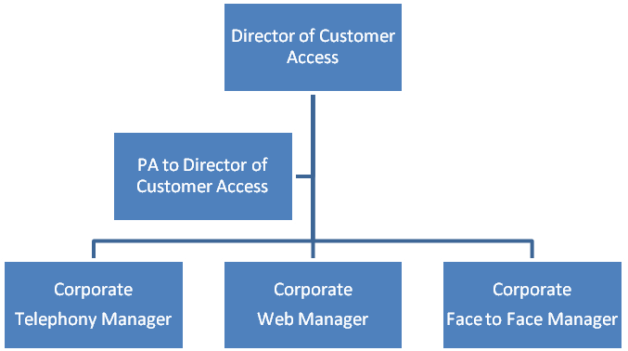
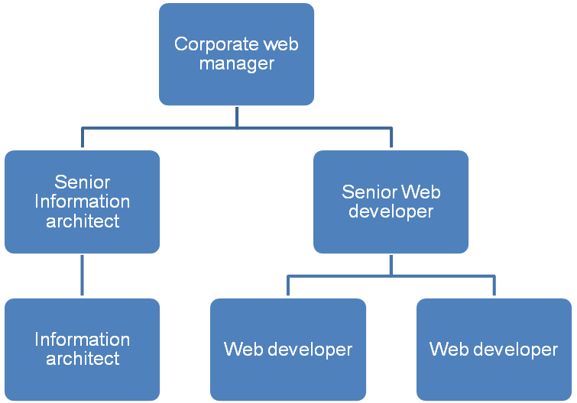
It is structured as follows –

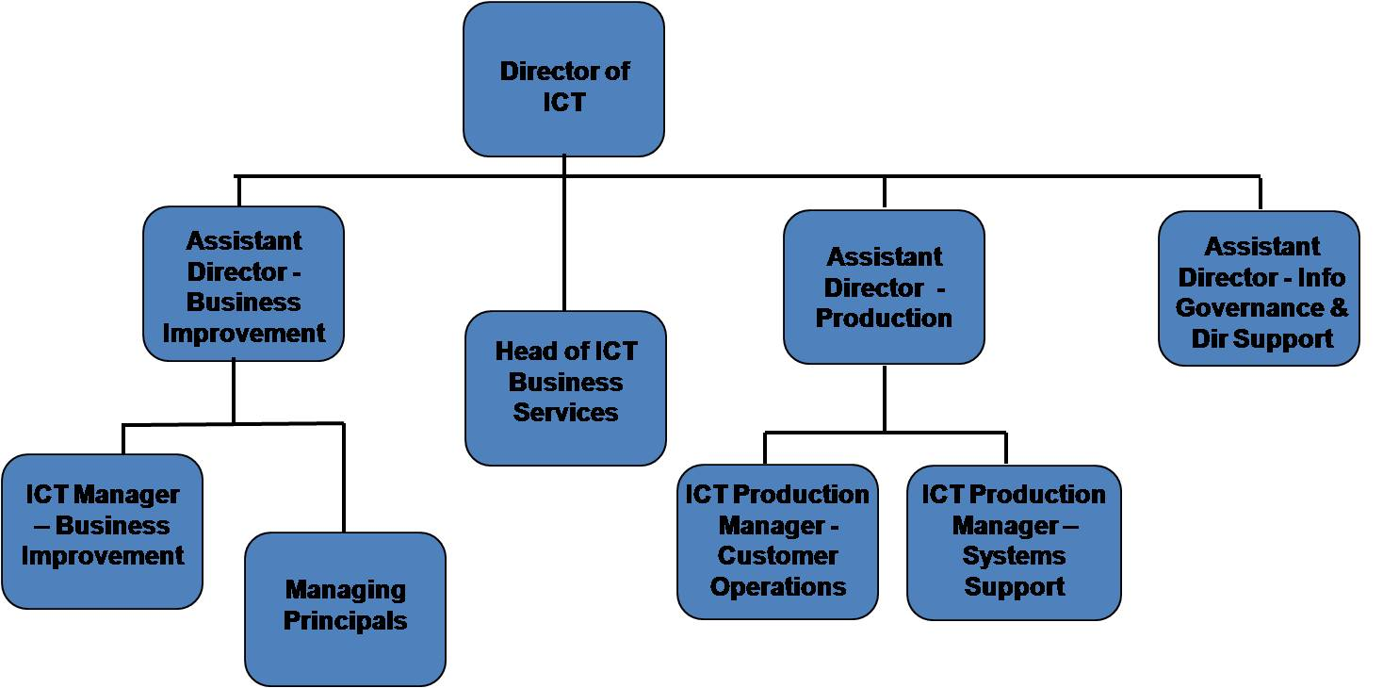
- ICT Services are situated within the Resources Directorate and are structured as shown below. Staff from all areas would have some involvement in management of the Web.

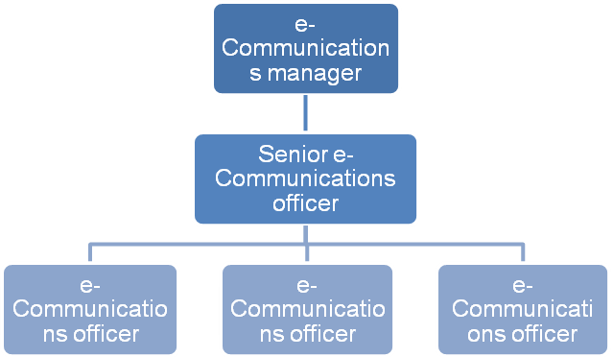
- e-Communications are based within the Communications service to ensure consistency of brand, identity and message across all electronic communication and marketing channels. The function is structured as follows:

f. Do any employees have access to social networking websites (twitter, facebook etc) as part of their role, ie running a twitter/facebook account for your organisation? If yes, please provide this person's job title and job description. If your organisation has a twitter account, please mention it's address.
Managing our corporate presences on social networking sites is one of the responsibilities of the e-Communication function. The roles identified in the e-Communications structure chart (see 4.) all have access to social networking sites as part of their duties, although in each case this accounts for a small minority of the postholder's time.
Our twitter account is www.twitter.com/lancashirecc
Further details are available on our website http://www.lancashire.gov.uk/corporate/web/view.asp?siteid=2846&pageid=33379&e=e

