

Aiming High for Disabled Children

Data Collection online tool

Guidance Document - Version 2

June 2010

This is a guideline to help you when entering information onto the AHDC Online Data Tool.

The tool collects data on the individual children and the number of hours or nights they have attended your provision.

If you are providing a GROUP based provision you will also need to supply the dates of the sessions, how many children attended the session and the length of the session.

The information will allow the AHDC team to;
- complete Government report
- monitor finance
- monitor provision
- prove growth
- plan for the future.

Your assistance to ensure that your data is input by the 9th of each month for the previous month would be very much appreciated.

Please do not forget that it is a requirement of your contract that you supply the data requested.

If you need any help please contact

Dawn Fenton – AHDC Participation, Information and Data Officer
Dawn.fenton@lancashire.gov.uk
07825755511

Sarah Berry – AHDC Administrator
Sarah.berry@lancashire.gov.uk
01772 536164

Aiming High for Disabled Children web site
www.lancashire.gov.uk/aiminghigh

Web address
https://lccsecure.lancashire.gov.uk/CYP/find/AHDC/login/login.asp

Your user name is AHDCXXXX – (where XXXX are unique numbers to your service)

You should have already received your password – if you do not know this please contact Dawn Fenton.

Once into the system you should be presented with this screen

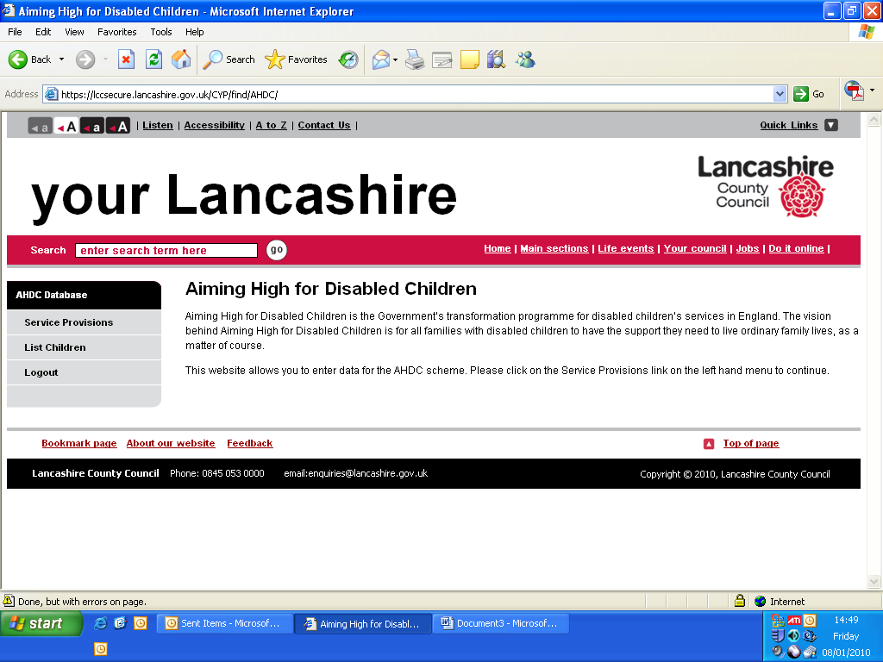
Screen Shot 1

If you click on the left hand link Service Provision the screen below should be shown. With the title 'Service Provision for XXXXXX' where XXXXX is your service name.
Here the service name is Display Service.

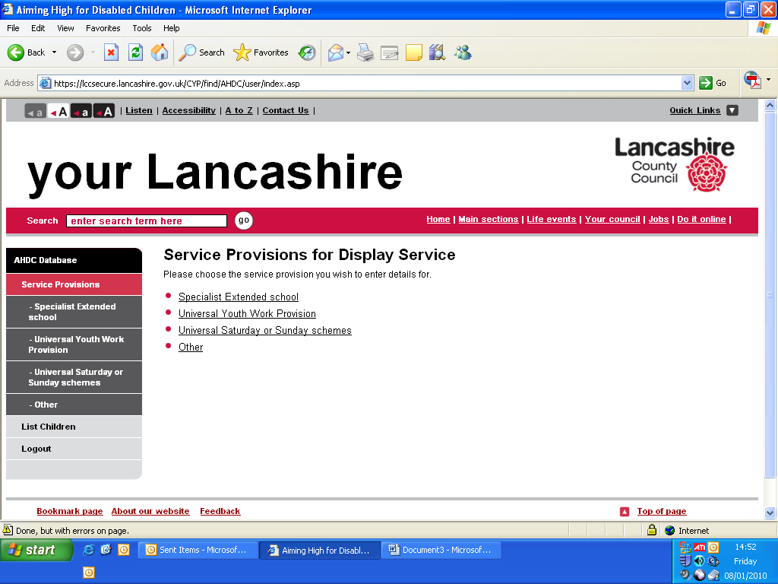
Screen Shot 2

If you click on the left hand link 'List Children' the screen below should be shown.

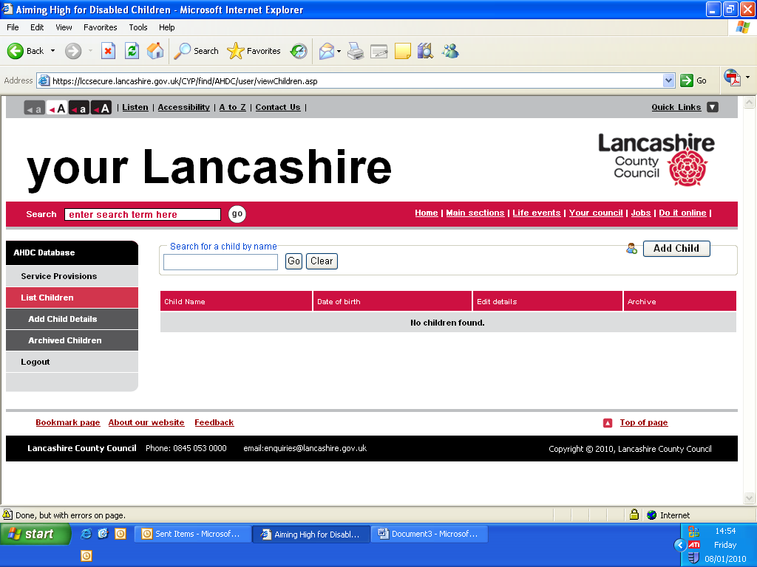
Screen Shot 3

This is the screen where you enter all the children's details who have attended sessions. This is only done once for each child as the information is saved.

Click on the 'Add Child Details' and add each child individually saving after each entry.

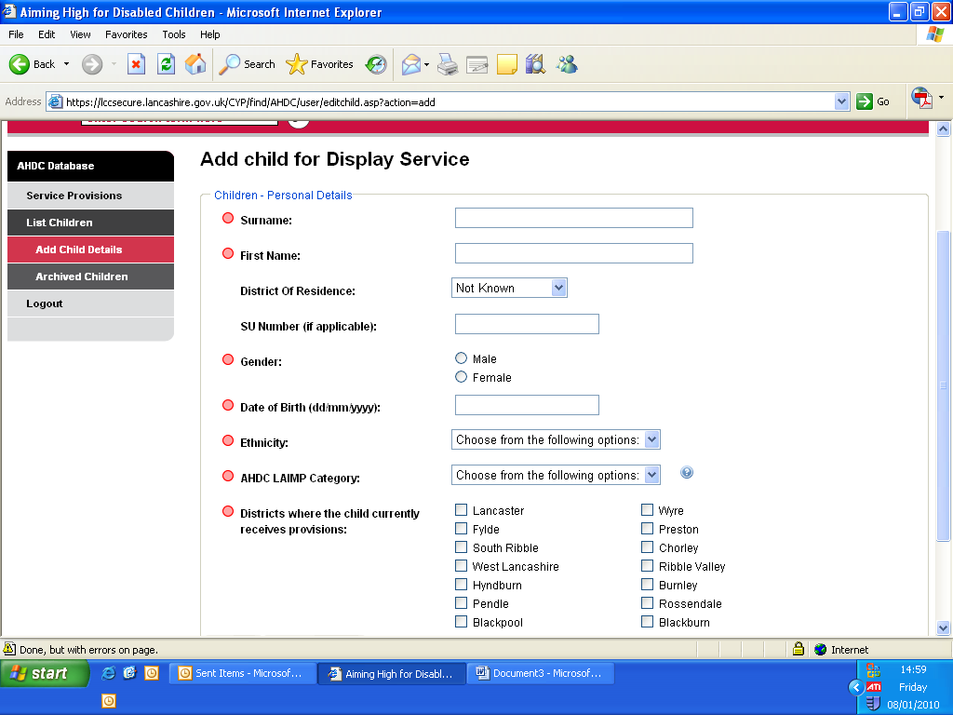
Screen Shot 4

Once all the children are entered and correct, the hours or nights attended by the child needs to be entered.

Go back to the 'Service Provision' link on the left and the screen shot 2 should be visible.

Here you pick up the sessions link you are inputting data for.
If you are unsure please refer to your awarding letter and check appendix 1.

If you are only providing INDIVIDUAL provision your screen will look similar to the one below

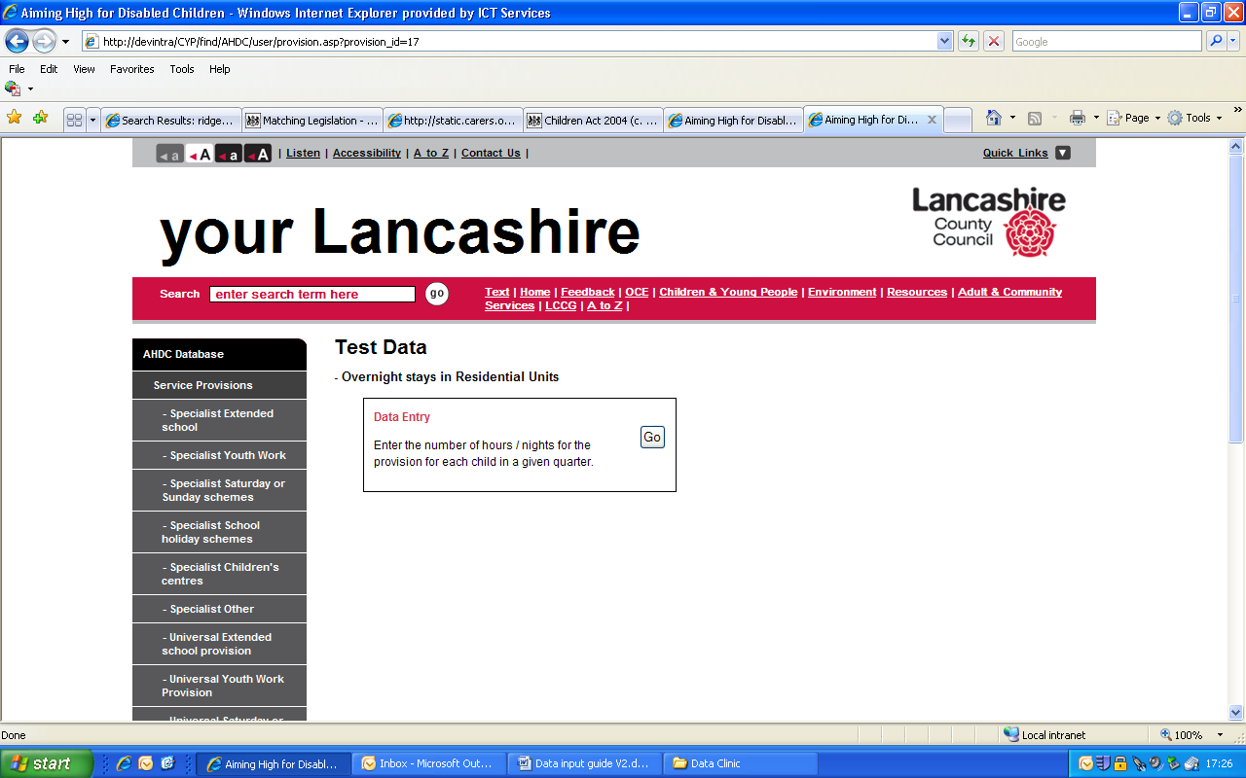
Screen shot 5

If you are providing GROUP based provision will be presented with this screen.

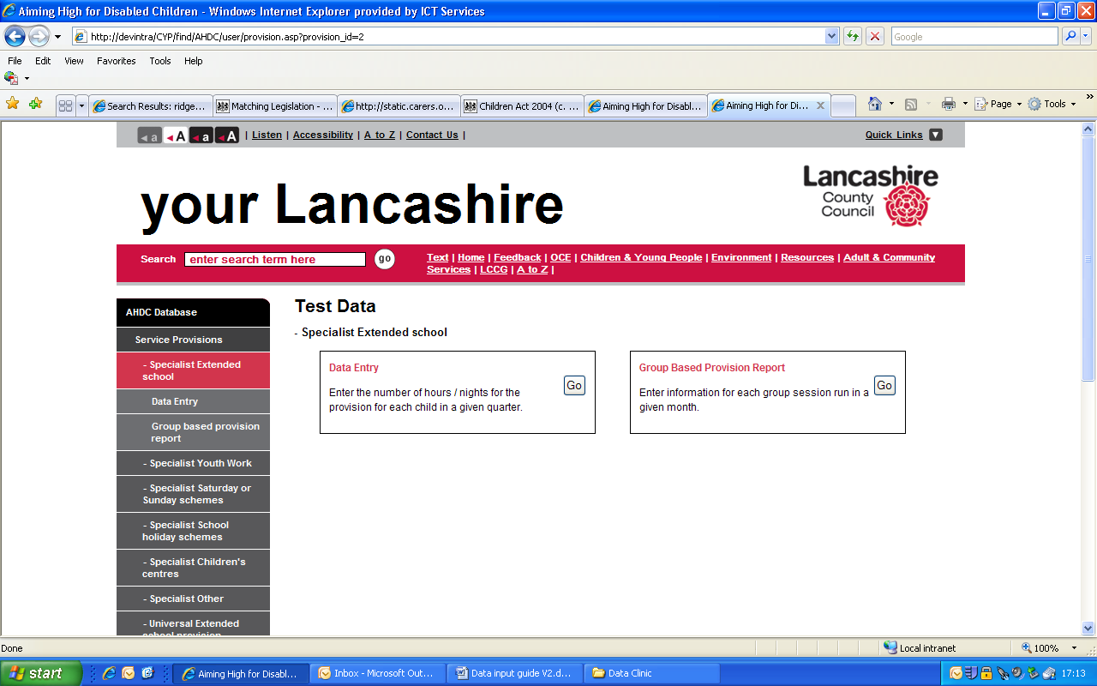
Screen shot 6

To add or update the hours a child has attended.
Click the 'Go' button on the 'Data Entry' box.

Once the 'Go' button is pressed the screen below is visible. Please check that the screen shows the correct provision as a heading.
The example below shows that 'Specialist Extended School Provision' has been chosen.

You will now be asked to add children to the provision

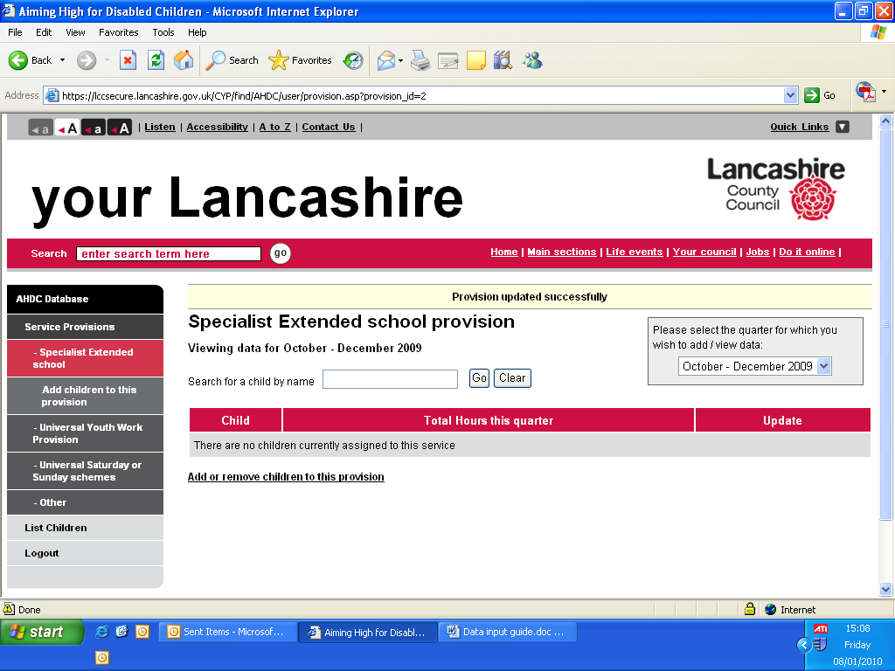Screen Shot 7
Click on the link Add or remove children to this provision
Now you will see this screen

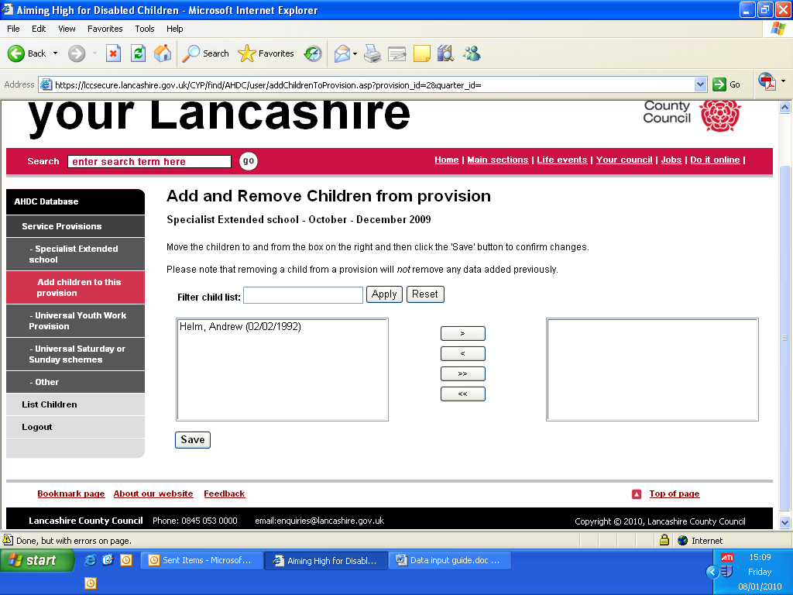
Screen Shot 8

Pick the child or children's name(s) from the left box list of names and using the middle arrows move to the right box. This adds the child / children to the provision type. Press 'Save' when all are moved from left to right.

Now a screen like this will appear with all the children you have selected listed. (this example only has one child listed)
Ensure that the correct quarter is displayed in the TOP RIGHT box.

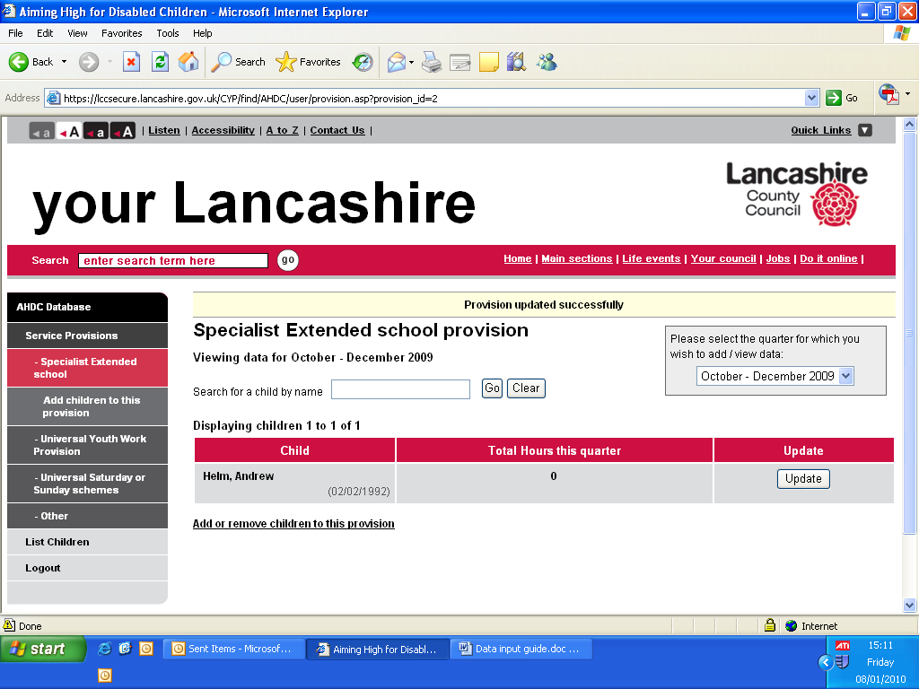
Screen Shot 9

Click the UPDATE button for the child that you are entering hours or nights information.
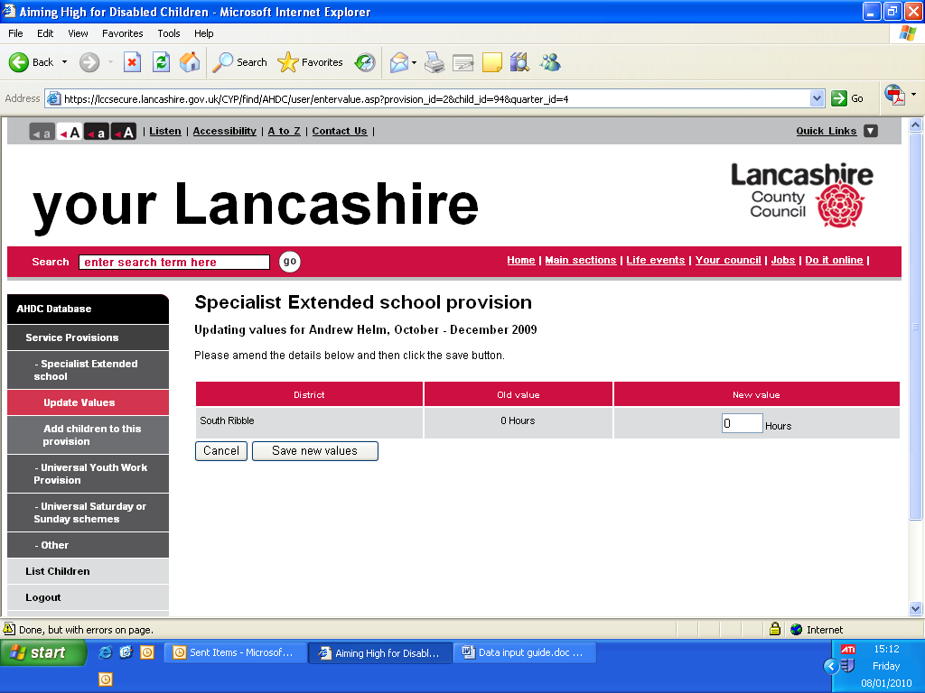
Screen Shot 10
Check date is correct

Now enter the hours that the child attended and then save. This can be updated throughout the quarter.
Some providers will have the word Nights rather than Hours.

Repeat this for each child and for each provision you are providing.

At the end of each quarter - March, June, September, December - the total for each child will represent the total number of hours or nights the child attended the provision.

If you are providing GROUP provision this will be compared to the data you supply in the provision tables – the guidelines for this are below.

If you are providing INDIVIDUAL provision this will correspond to information INCLUDED IN YOUR CONTRACT.

The rest of the guidelines are for GROUP based providers ONLY

Go back to the screen below screen shot 6.

From here you can update the session dates, attendance and session length you have provided.

This needs completing for each month by the 9th of the following month.

Click the go button on the Group based provision box.

Screen shot 6

You will then be presented with this screen – this takes the place of the monthly form you have been e-mailing.

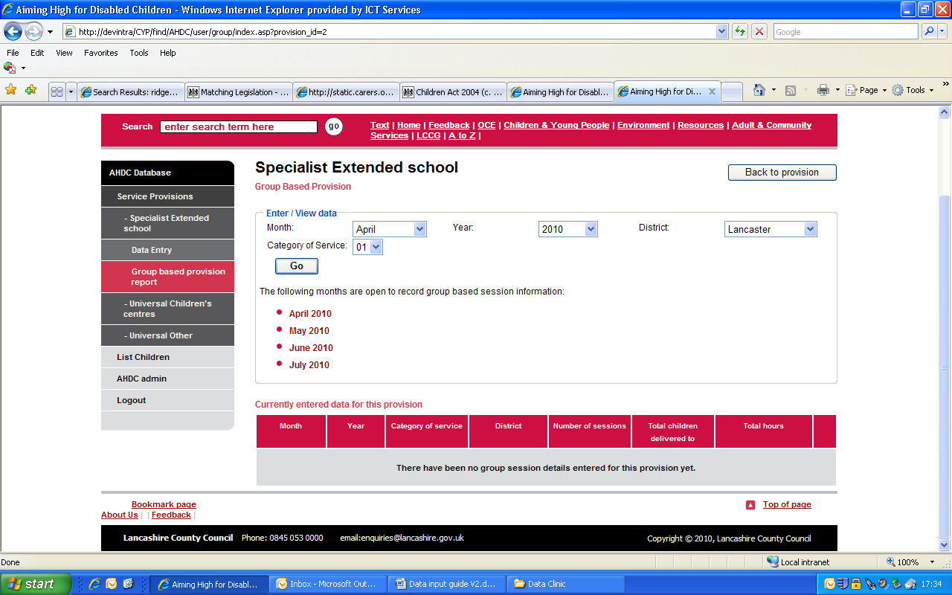
Screen shot 11

From this screen ensure all the drop down boxes are showing the correct data. Month, Year, District the provision took place in and the correct category of service.
If in doubt please check with appendix 1.
Once everything showing the correct details press the go button.

You will then be presented with a screen similar to this.
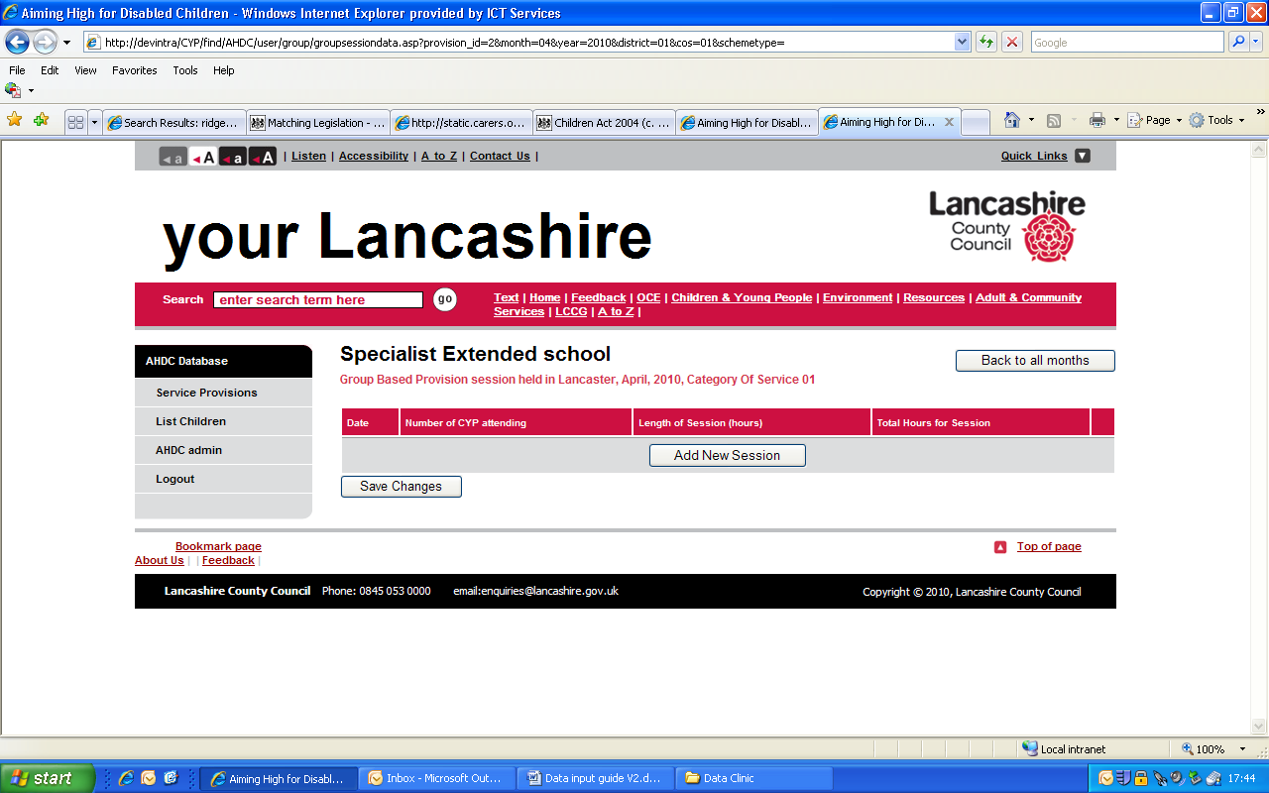
Screen shot 12

To add dates of new sessions press the 'Add New Session' button.

You will now see the input boxes below
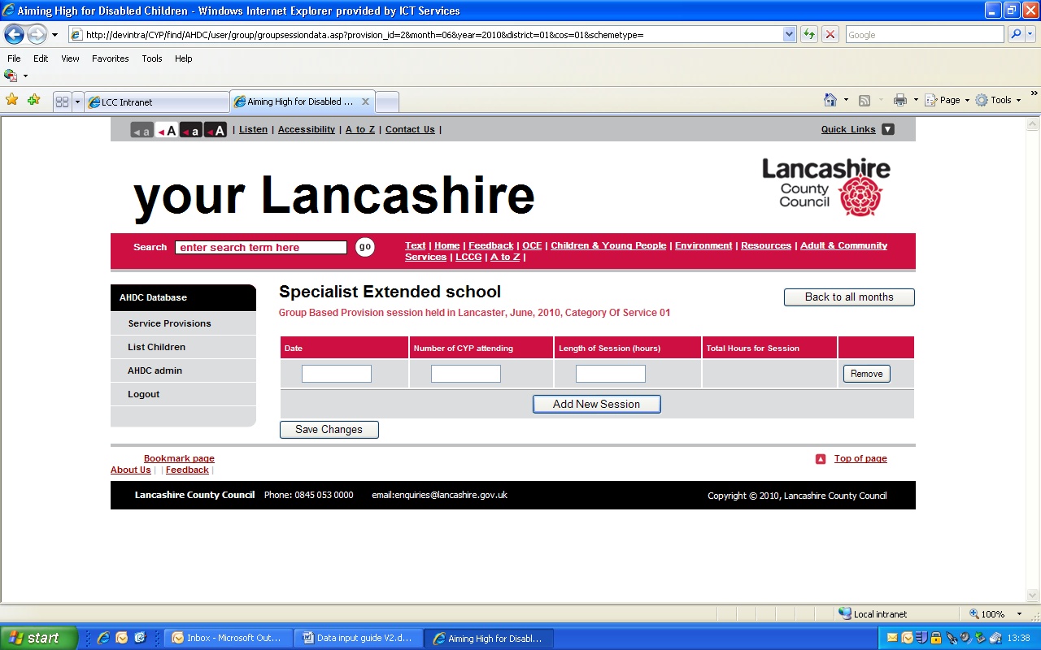
Screen shot 13

Enter the date of the session, length of the whole session and number of children who attended.

The total hours for session will update automatically.

If you have a few session dates to add click on 'Add New Sessions' button. When you have finished click the 'Save Changes' button. A bar at the top will state the changes have been made.
This table can be updated at any time during the month and up to the 9th of the following month.

After the 9th of the month, the previous month will be closed and no more data can be added or changed.

For Services delivering more than one provision under category 15
ONLY

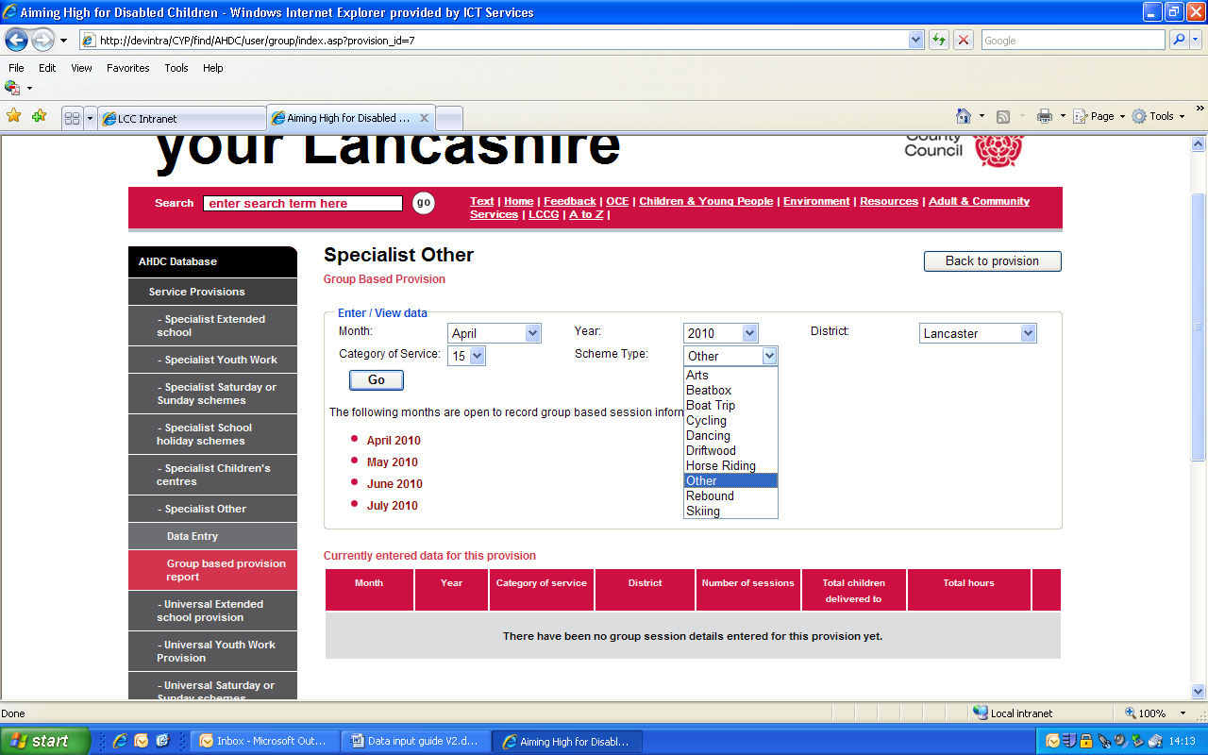
Screen shot 14

When inputting session information for category 15 you will see the screen above with the extra box 'Scheme Type'.

If you are only providing one session the default in the box is 'Other' there is no need to change.

If you are providing more than one you will have called your provision a 'Name' in the application form.

The drop down box includes the names of the schemes.

Pick your scheme name and carry on as from Screen Shot 11.

Appendix 1

Continued Appendix 1

