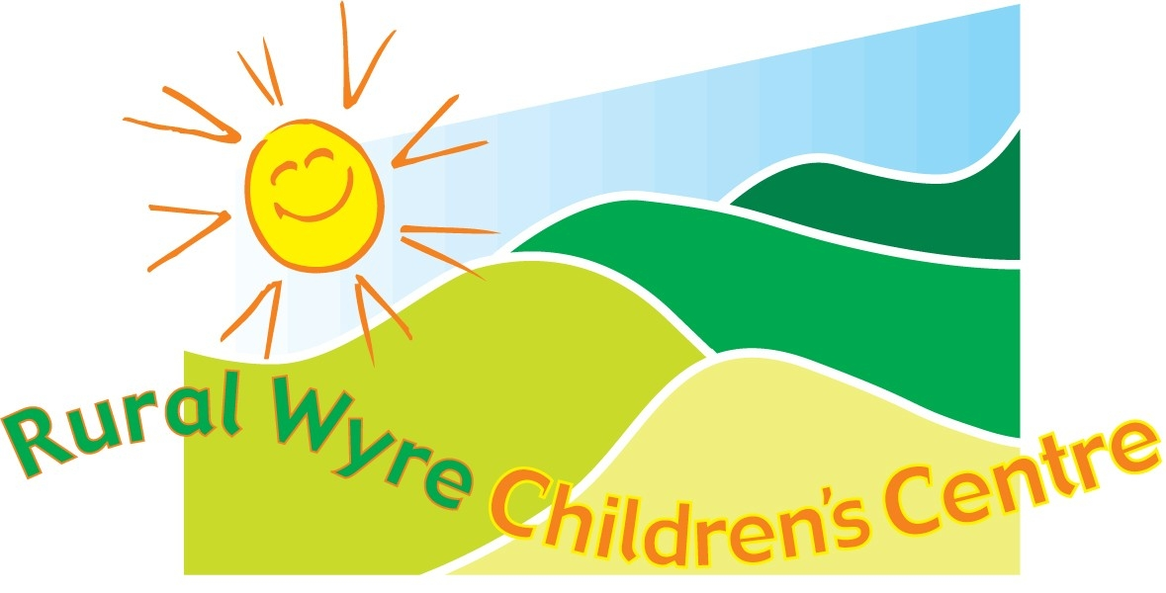
Welcome to RWCC’s autumn newsletter!
We have listened to your ideas & feedback regarding activities & courses and we have taken them into consideration in our planning for the autumn term.
Our programme overleaf lists our activities, courses, trips and events until Christmas. We look forward to seeing you at the Centre and at our satellite groups in the Rural Wyre Communities.
We have several NEW activities starting up, so be sure to book a place at any of our groups if you are interested as numbers and crèche places are limited!

‘Open House’

When: 19th September
Where: RWCC
Time: 9am – 1pm
Not sure what we’re all about!
Pop in to our ‘Open House’ event and meet the team. We will be around to answer any questions you have about the service we offer.
See you there!
P.S Car Boot Sale also on at
Garstang St. Thomas's School
8.30am- 1pm


1st Edition
Sept – Dec '09
Donations
We do not charge for our groups, however: donations for refreshments are welcomed.
Thank you!







1 Stop Information Shop
3rd Sept & 5th Nov – 1pm – 3pm at
Preesall & Knott End
Youth & Community Centre
Lancaster Road - FY6 0ER
And 5th Oct - 9.30am – 11.30am
at Rural Wyre Children's Centre
Advisors available on a one to one basis from:
Job Centre Plus
HM Revenue & Customs
Re: Child Tax & Working Tax credits
Start Now
Employment needs
Preston College
Adult training
Face to face
LCC enquiries
Next Step
Careers service for the over 20's
Please ring for further details

Christmas Activities
Pantomime Trip at Charter Theatre, Preston
CINDERELLA!
9th Dec -Garstang & area families
10th Dec - Over Wyre families
Book your subsidised transport & tickets at our groups.
Limited places available!

The groups below will not be running
Baby signing on 25th Sept
Parents café on
29th Oct & 10th Dec
Teenies on 10th Dec.
Thank you

Beacon Fell
25th November
Join us as we hunt for a special Christmas tree to decorate
our Centre!
Book a place at any of our groups!

Tattybumpkin

Tattybumpkin and the classes were born out of yoga & fun! It is a movement & sensory opportunity, exploring the world of Tattybumpkin through story & music.
Come and join Tatty, & spend some quality time
sharing & learning together. Suitable for
pre school age children. See over for details!

Stay & Play Groups
Our stay & play groups are planned to promote areas within the Early Years Foundation Stage!

Baby Massage
For babies from 8 weeks to pre mobile
May help with sleep problems, colic, constipation, relaxation and bonding.
Dads & Grandads
If you have any ideas for a dad's group – call us & let us know! We value your input!
In addition to our activities, experienced staff are available to offer support & information on issues around parenting. Please call, or drop into the centre for more information.
Children's Centre Services coming to Pilling.

Autumn 2009!
Look out for further details!

