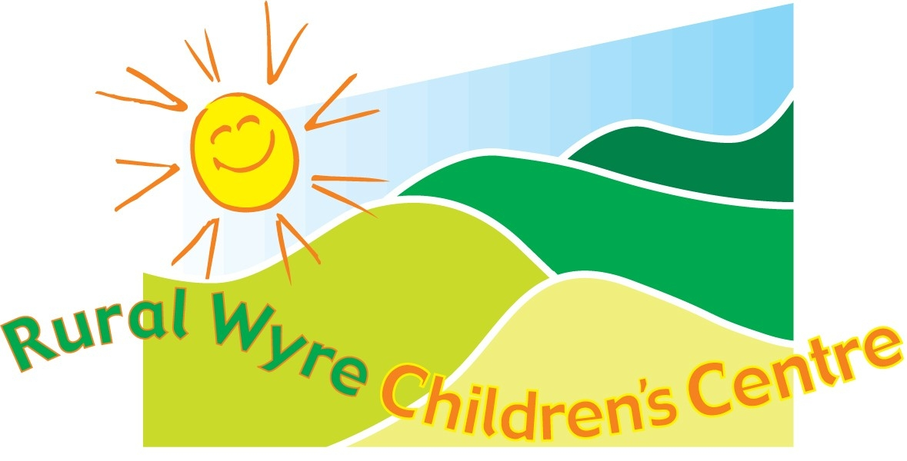
Monday
Tuesday
Wednesday
Thursday
Friday
Stay & Play for Under 5's
Starts 16th Nov – 14th Dec
9.30 -11am
Play sessions for you & your child
Positive Parenting Course
22/09/09 – 15/12/09
10am – 12 noon
12 week parenting course Crèche provided. Please
book a place.
Registration Sessions
09/09/09 – 10am – 12 noon
04/11/09 – 6pm 7pm
An opportunity for expectant parents to come along and register – meet others!

Baby Signing
Singing & Signing Classes
Led by Tiny Talk Instructor
11th Sept – 23rd Oct
10am – 10.45am
No session on 25/09/09

Parents Café
Start 10th Sept
8.45am – 9.30am
Call in for a cuppa and a chat!


Your Bump & Beyond
1pm – 2.30pm
Course 1 07/09/09 – 12/10/09
Course 2 02/11/09 -07/12/09
Group for expectant & new parents. See the midwife!

Fishing 4 Fathers
24th August
7th, 14th & 21st Sept
6pm - 8pm
One on one fishing activity for you and your child
Please ring Lee to book a place

Chatterbox Sessions
Moss Side Nursery Stalmine
9.30 – 11am
14/09/09 – 19/10/09
Activities to help your children become little chatterboxes
Sorry - no session 5th Oct

Parent / Carer & Toddler
Drop in Sessions
2pm -3pm
St John's School Calder Vale
5th Oct, 2nd Nov & 7th Dec
Tattybumpkin
St. Williams School Pilling
Taster on 20th Oct 9.30 -11am
A 6 week multi-sensory movement programme for Pre school children & their carers.
Course starts 3rd Nov - 8th Dec
9.30am-10.30am

Registration Sessions
06/10/09 - 1pm -3pm
01/12/09 – 1pm -3pm
An opportunity for expectant parents to come along and register – meet others!
Parent / Carer & Toddler
Drop in Sessions
Bilsborrow John Cross School
10am-11am
8th Sept & 6th Oct
3rd Nov & 1st Dec

Childminder Drop in
Scorton Village Hall
15th Sept & 6th, 20th Oct
3rd, 17th November
1st, 15th December
9.30am – 11.30am

Paediatric First Aid Course
Covers scalds, choking & resuscitation
16/09/09 - 9.30 – 12.30
Crèche provided.
Please book a place

Anger Management Course
23/09/09 Taster session 10am
4 week course
9.30 – 12 noon
30/09/09 – 21/10/09
Please ring to book a place

Stay & Play for Under 5's
Hambleton Village Hall
term time
9.30am -11am

Parent / Carer & Toddler
Sessions
Knott End Library
10 am - 11.30am
16th Sept / 7th, 21st Oct
4th, 18th Nov / 2nd, 16th Dec

Chatterbox Sessions
10. am – 11.30am
24th Sept – 22nd Oct
Activities to help your children become little chatterboxes

Teenies
Starts 5th November
Pre mobile baby play session
10.30am – 12 noon

Mum's the Word
Breastfeeding Support
BfN supporter at sessions
1pm – 2.30pm
Drop in & meet others!
Due to building work, the Stay & Play Group for U5's at St Williams School, Pilling will temporarily take place at a venue close by. Further details to follow!
Parent / Carer & Toddler
Drop in Sessions
Bleasdale School
2pm – 3pm
24/09/09 & 22/10/09
26/11/09 & 17/12/09
Baby Massage
6th Nov – 18th Dec
10am – 11.30am
Learn the art of baby massage
Please ring to book a place
Jo Jingles
Music, Singing & Movement Classes
12.45 – 1.30
Course 1 - 11th Sept – 16th Oct
Course 2 – 06th Nov – 11th Dec
Please ring to book a place
Please read our newsletter overleaf for updates to our programme, including trips, workshops & latest information
Saturdads
RWCC & YMCA
One on one activities for you & your child
10am -12noon on 3rd Oct
7th Nov & 5th Dec
Please ring Lee to book a place

